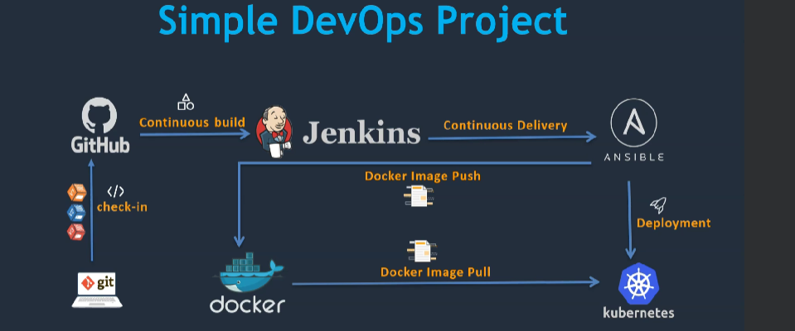  
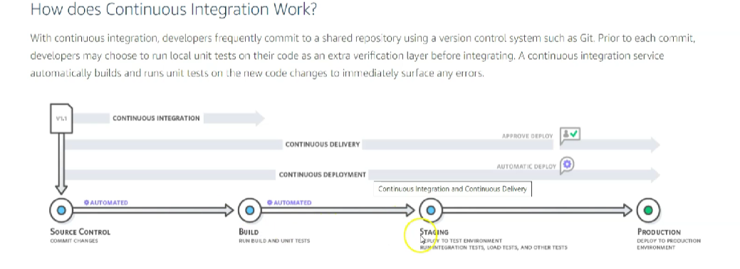  
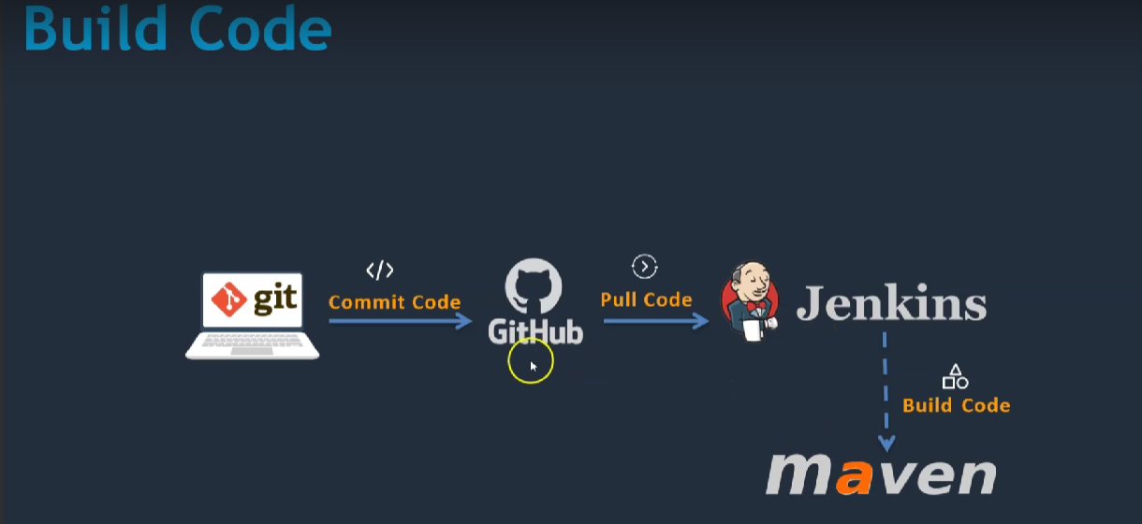

**Installation of Jenkins:** Creating instance on AWS:   
 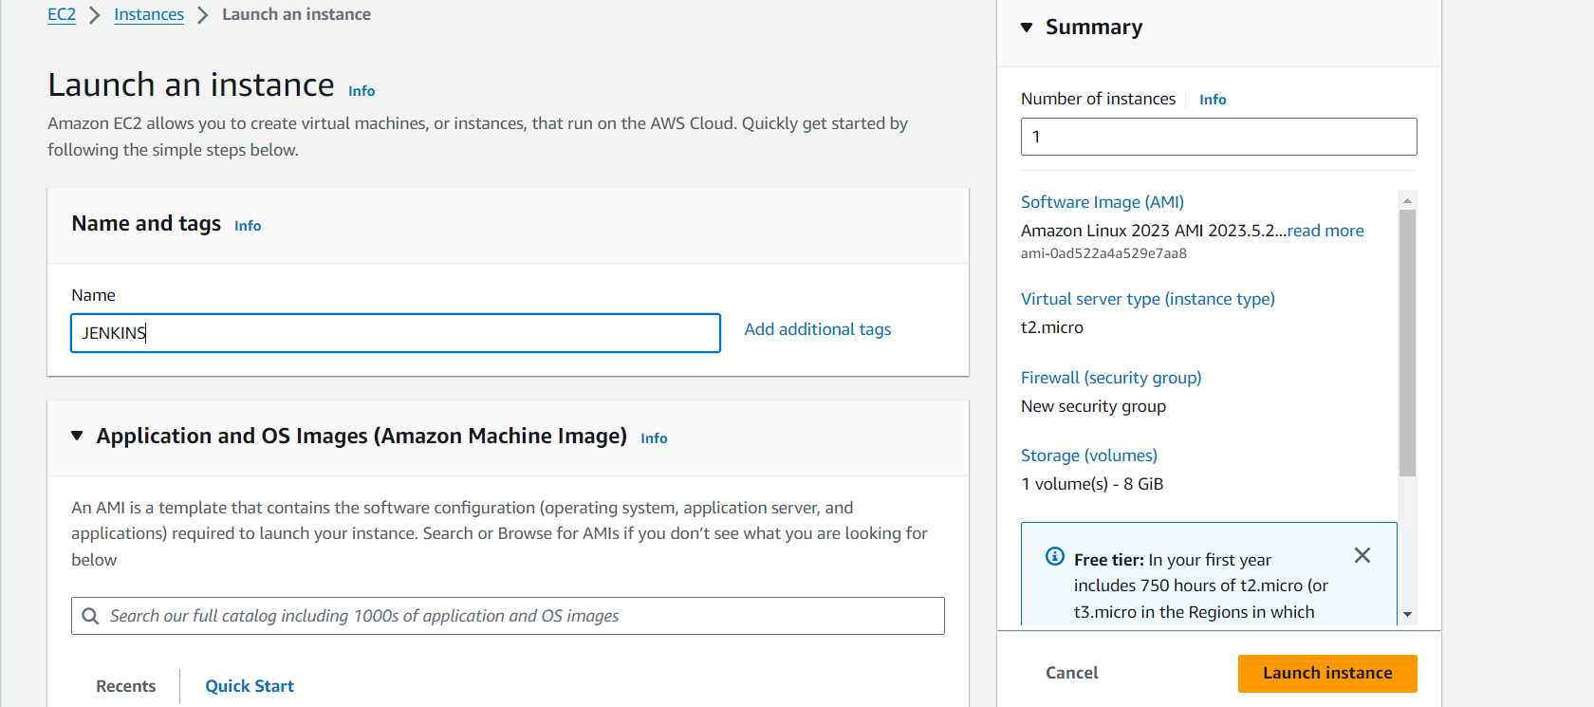  
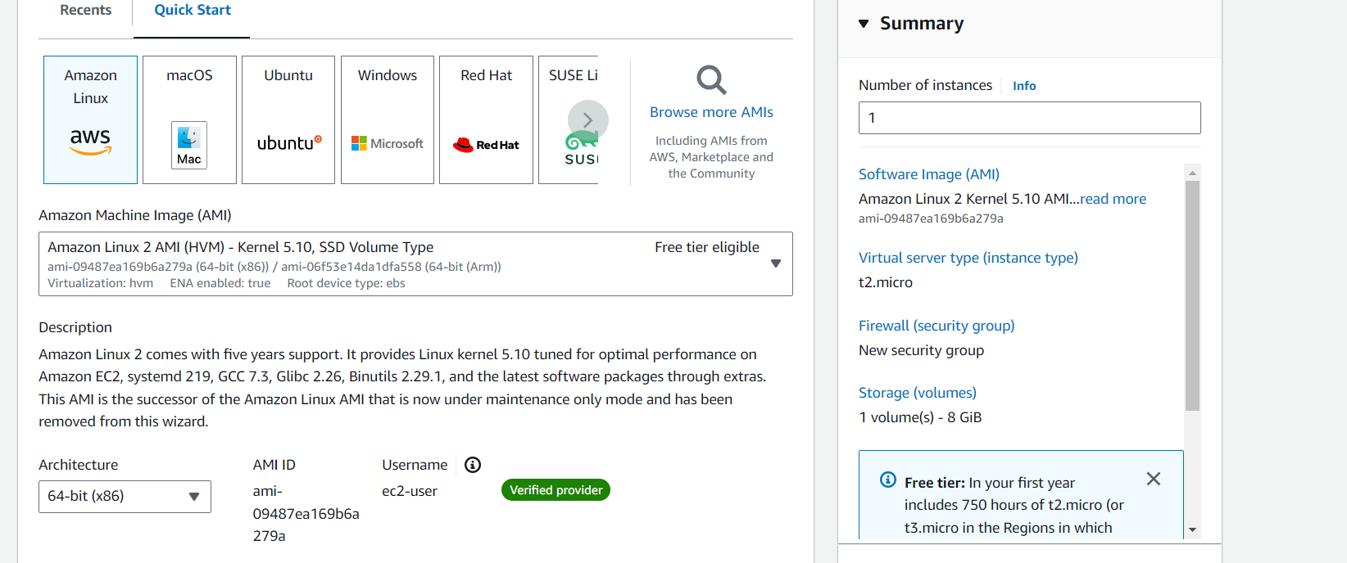

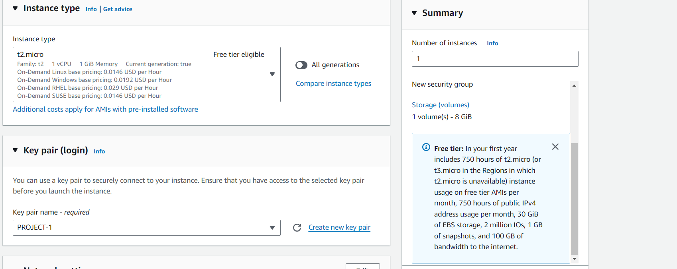

Creating Keypair:

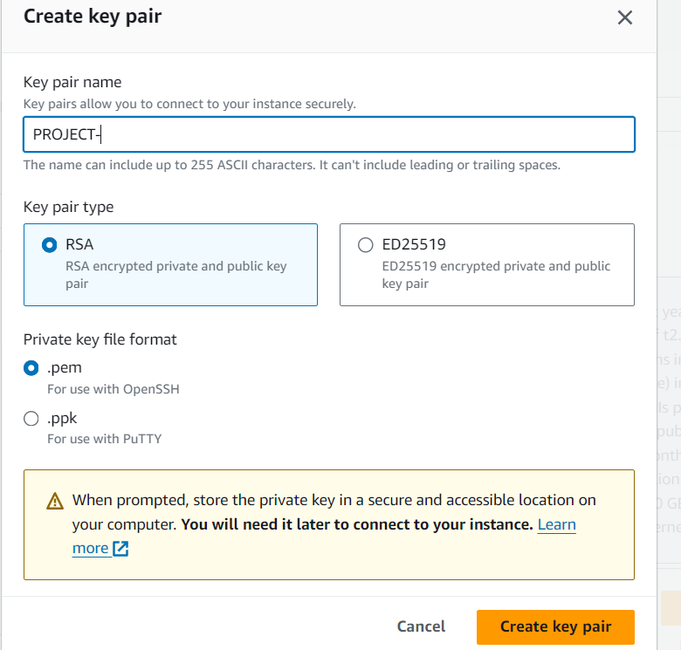

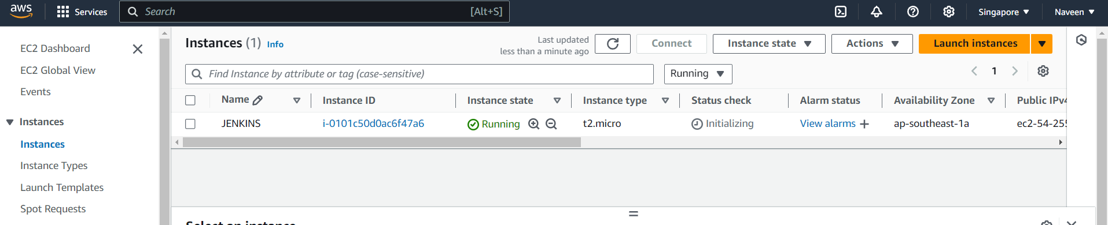  
**Setup the jenkins server:   
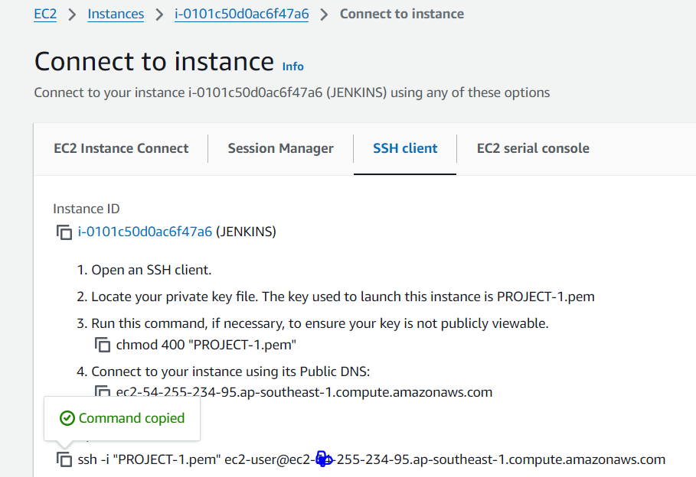**

**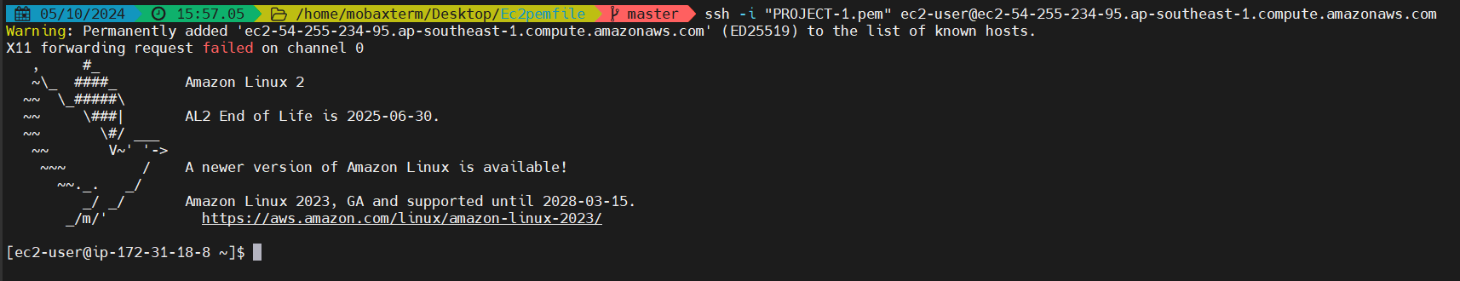  
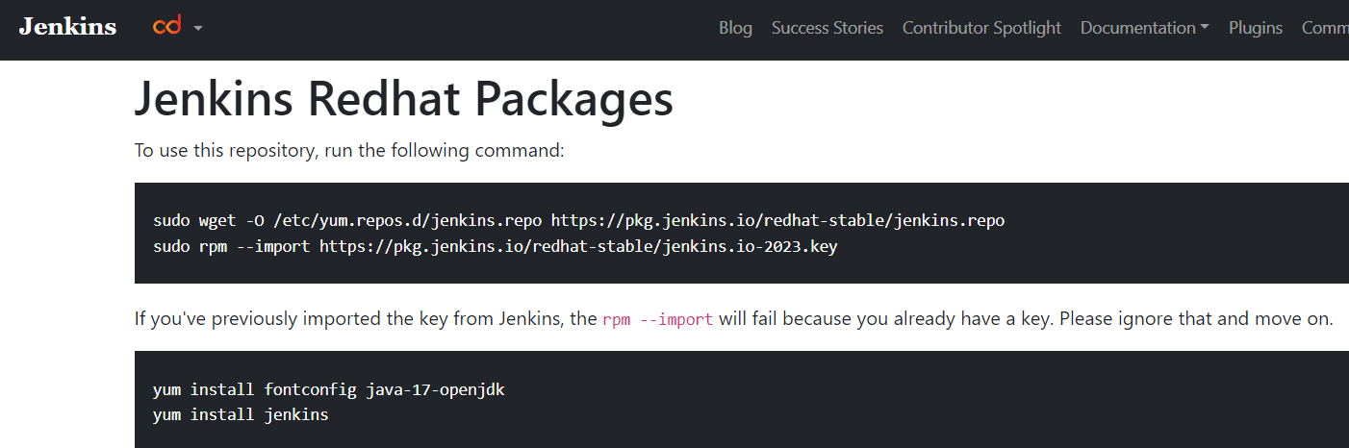**

**Installing Jenkins Packages and Keys:**

**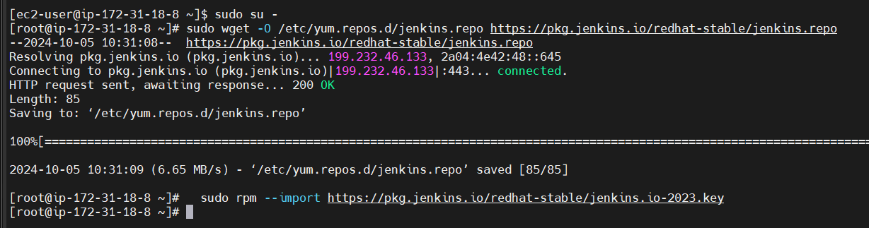  
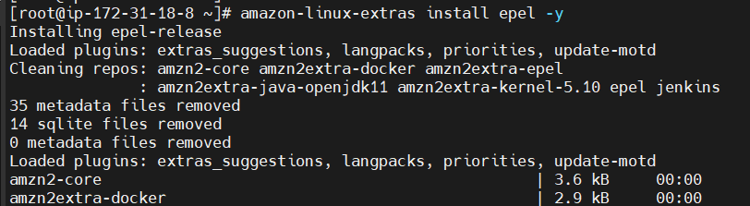  
Java installation:  
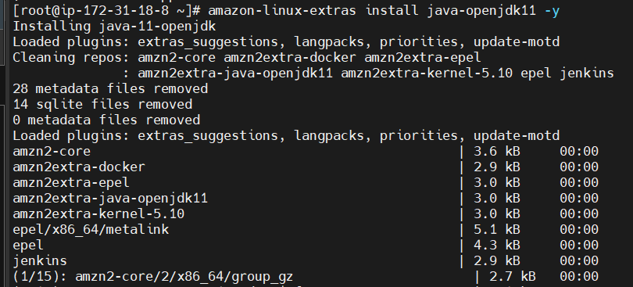  
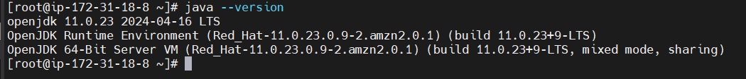  
Installing Jenkins:  
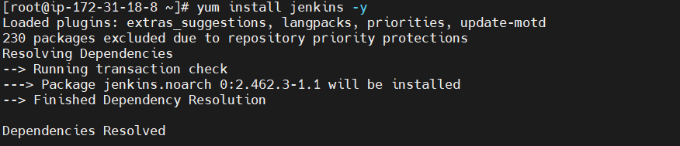**



**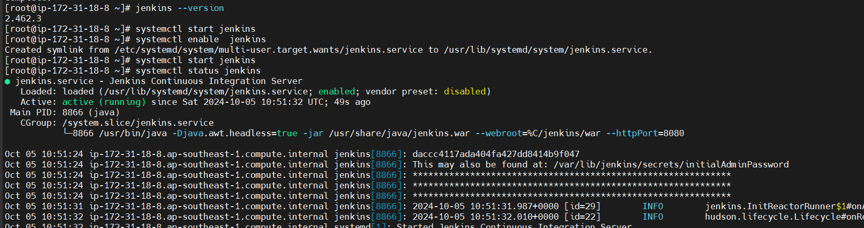  
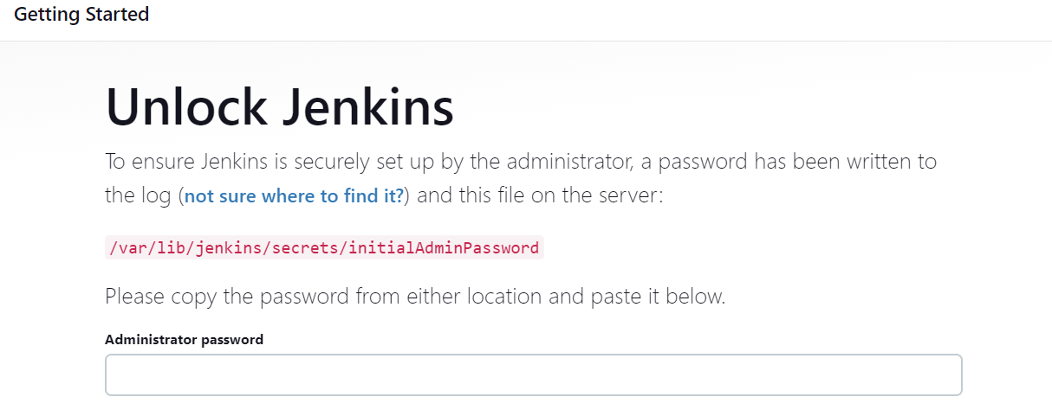  
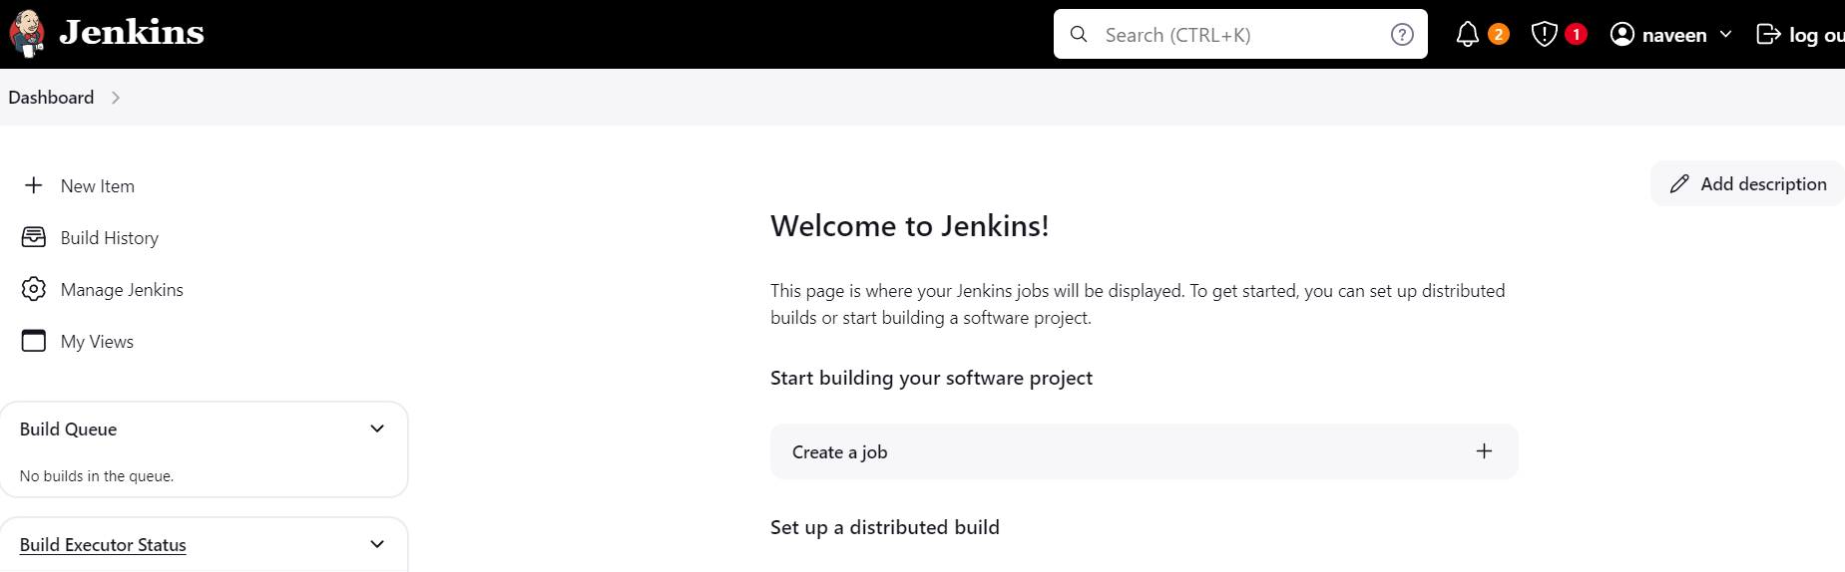  
Installing the github plugin:  
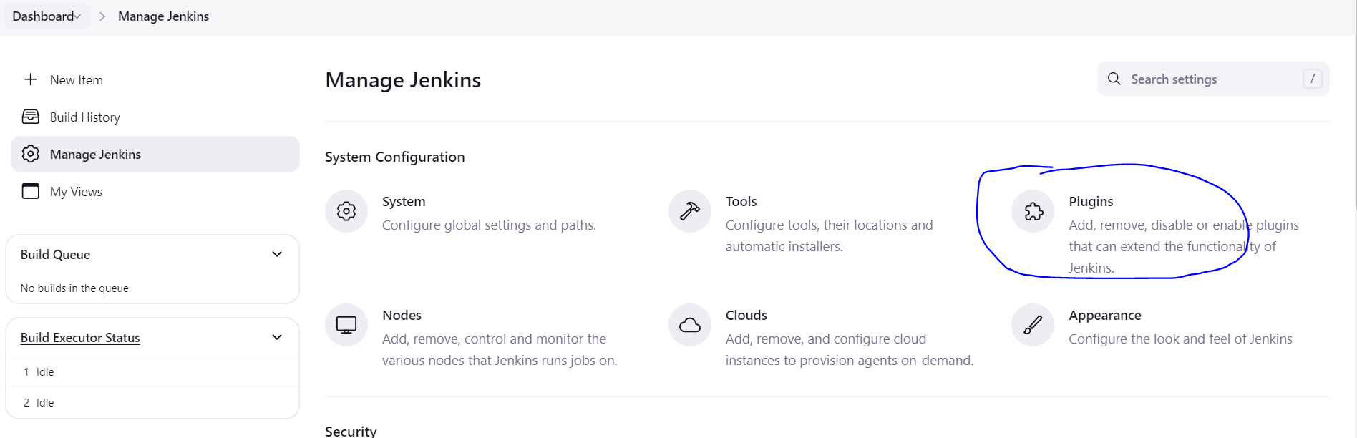**

Run and pull code from GitHub:

**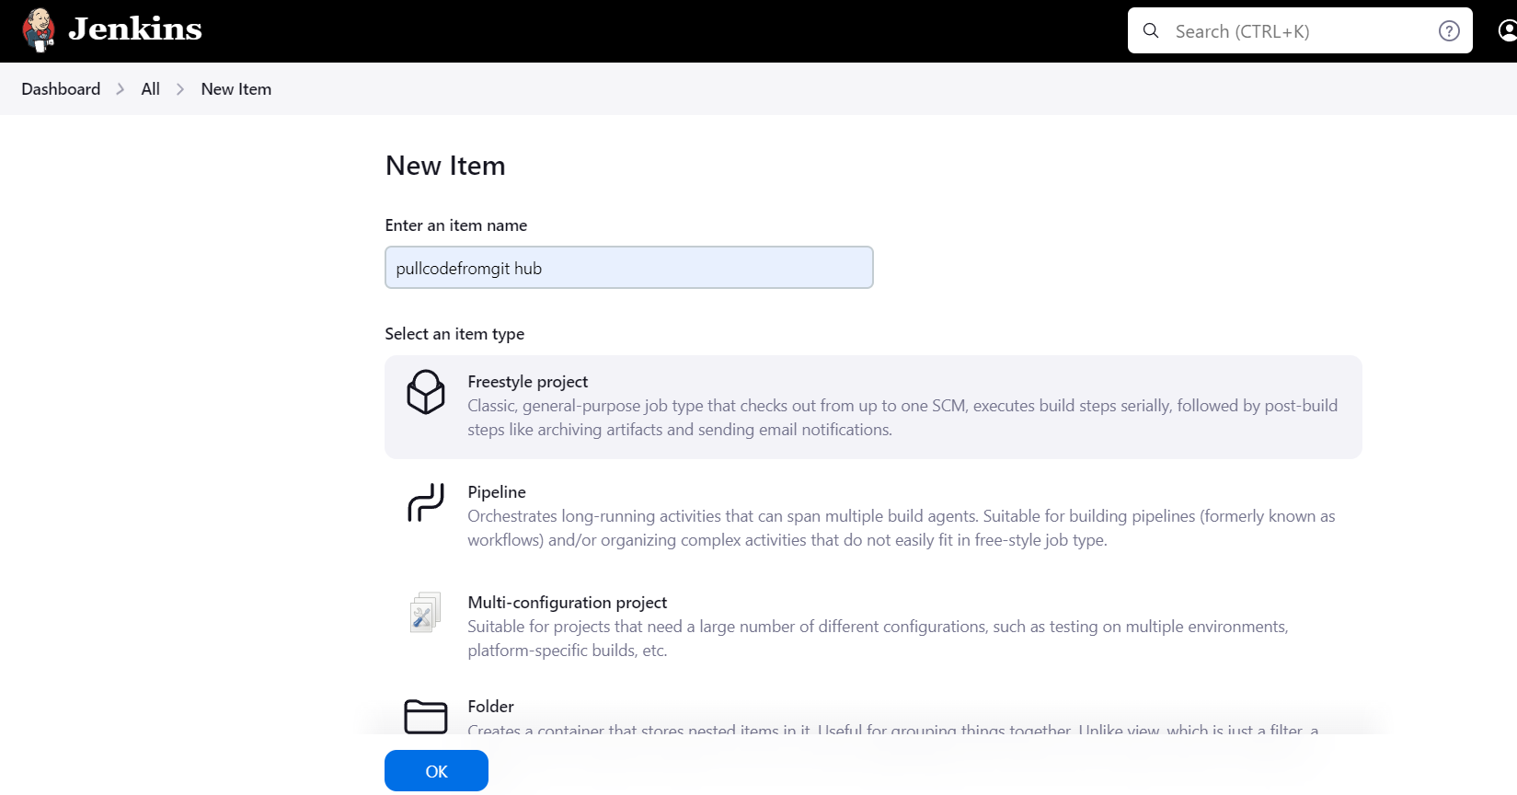  
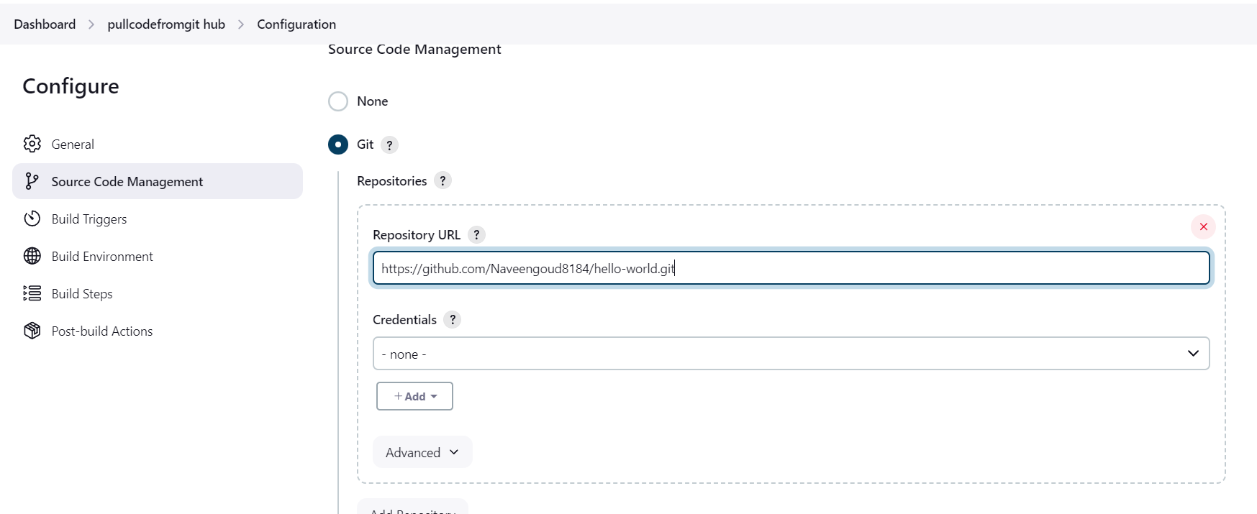  
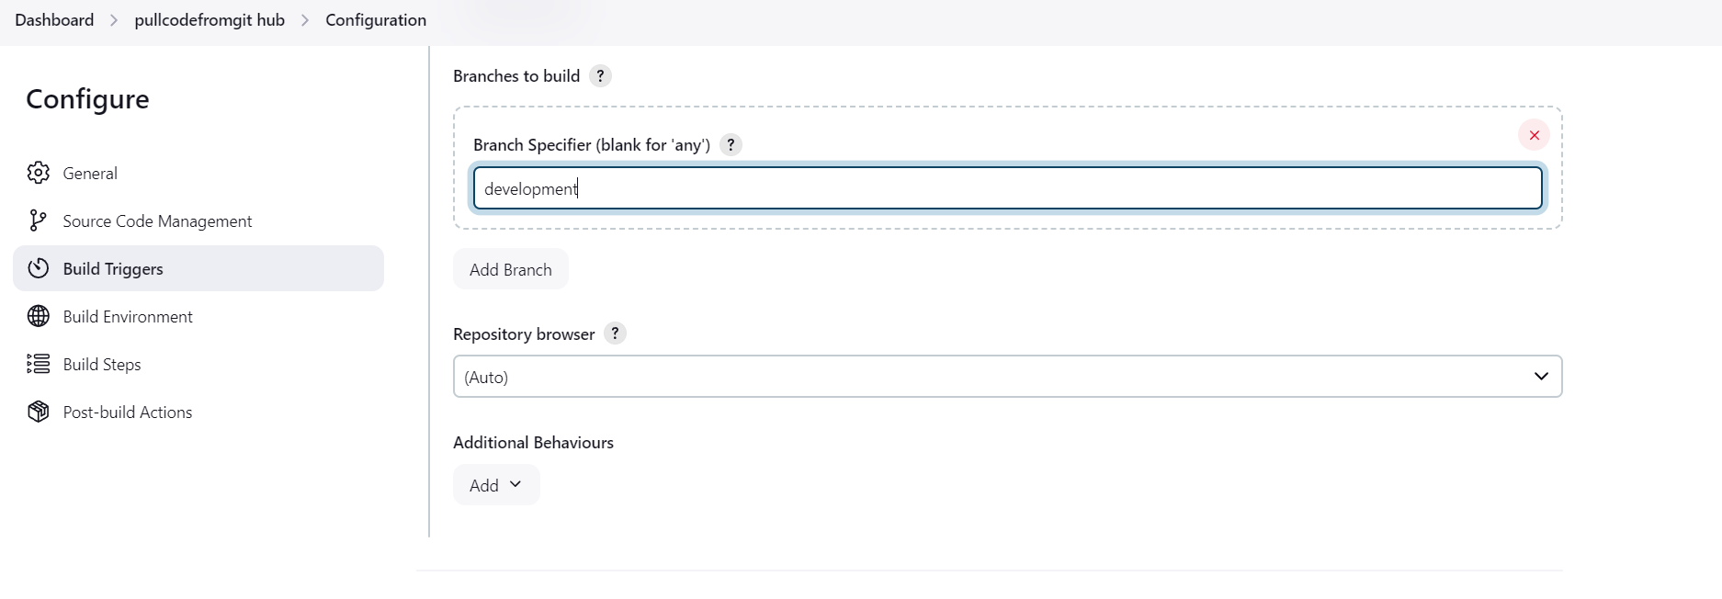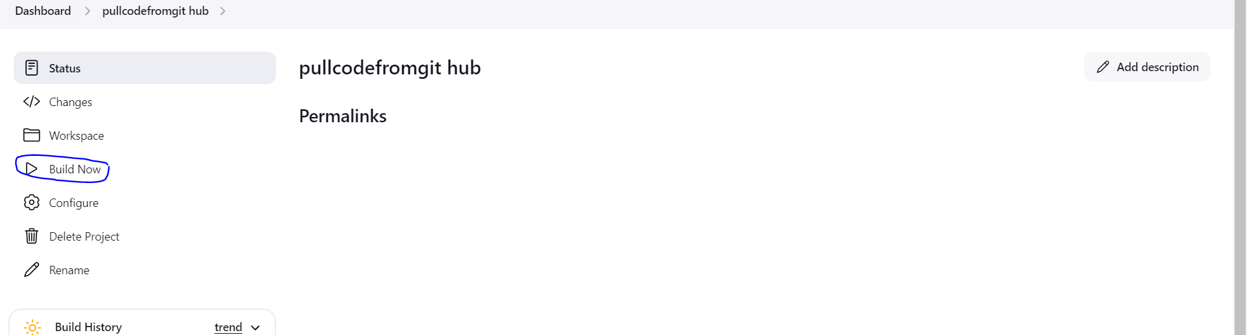  
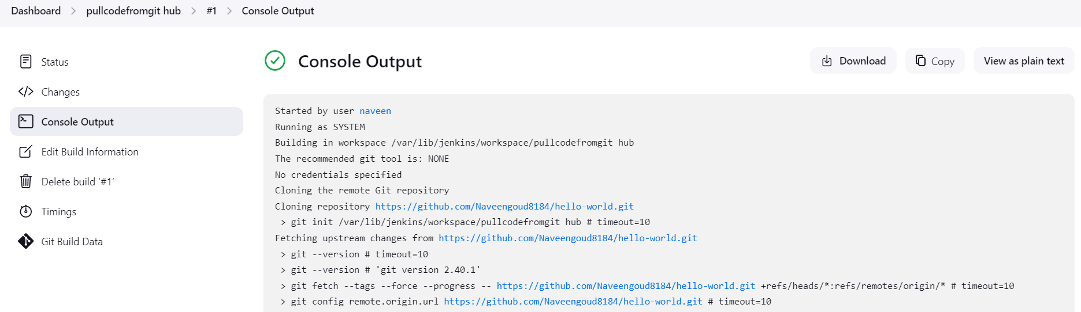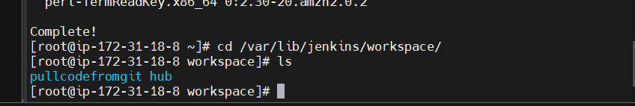  
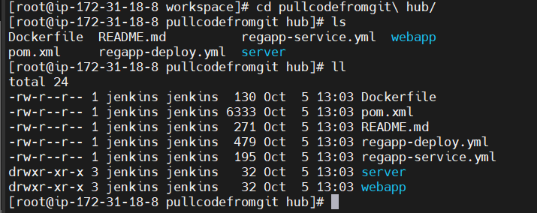**

Integrating Maven with Jenkins:  
 Maven Installation:  
   
  
Updating Bash_profile:   
  
Installing Maven Plugin:

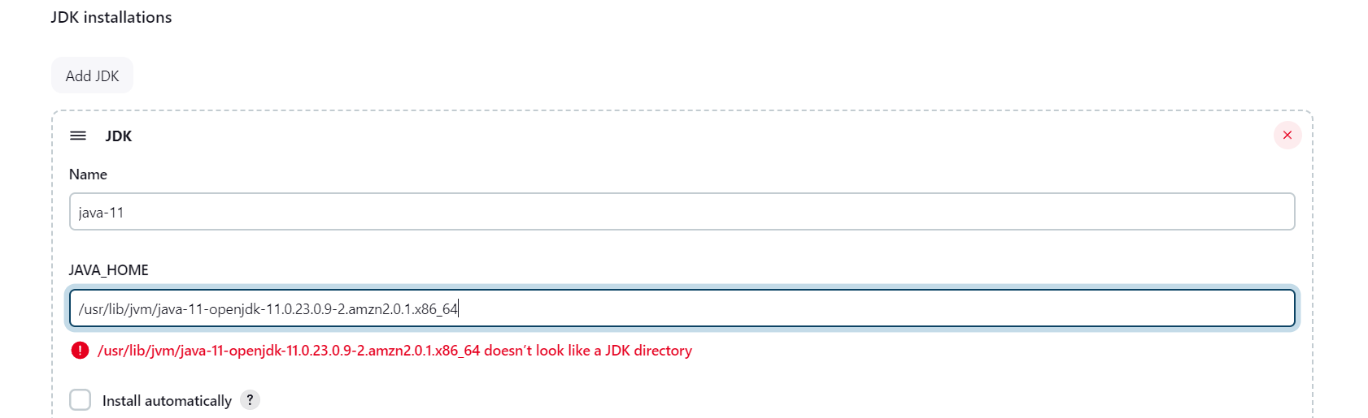

**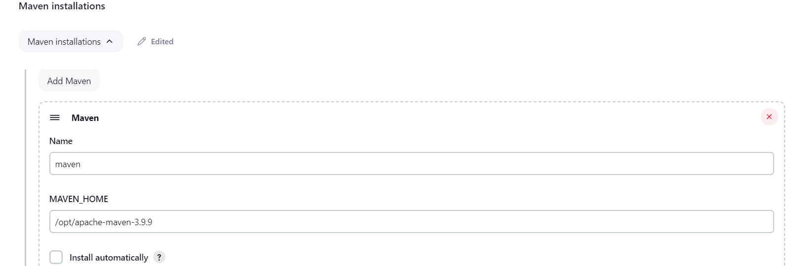  
Configuring Maven To Jenkins:**

**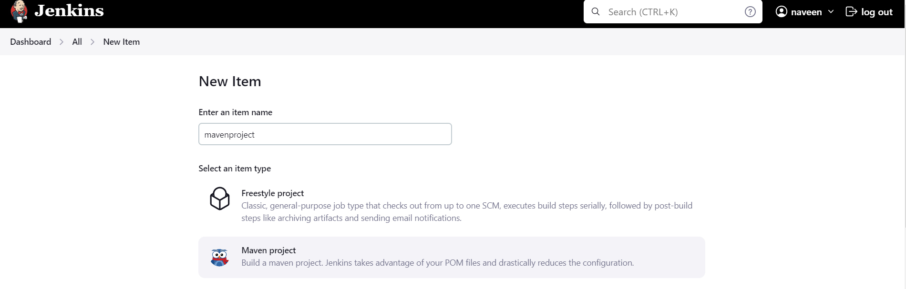  
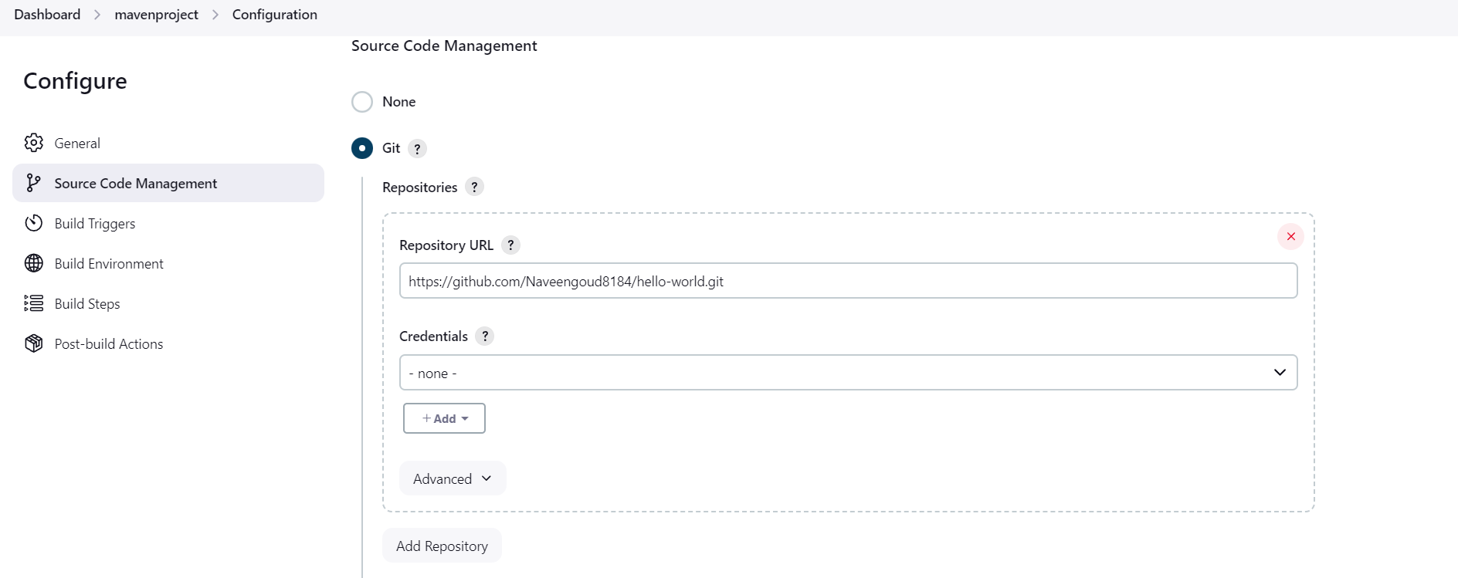  
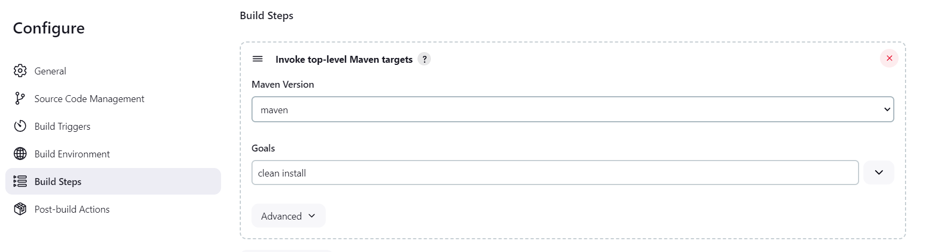  
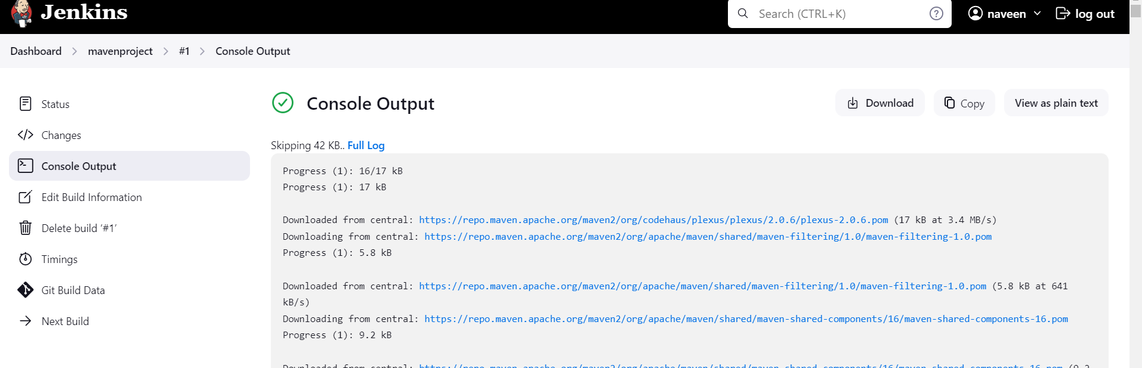**

**Jenkins server:   
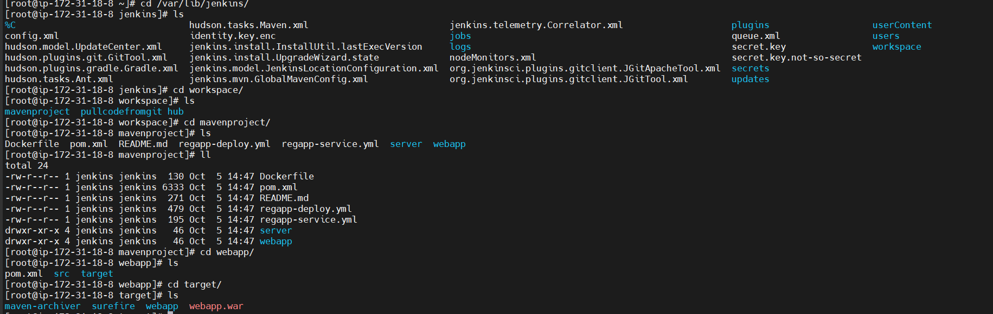**

**Deploy Artifacts on a Tomcat Server:  
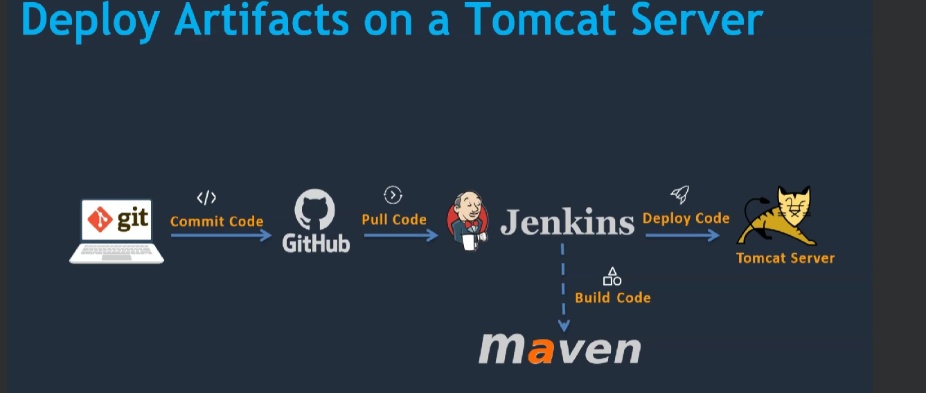  
Creating Tomcat Server:  
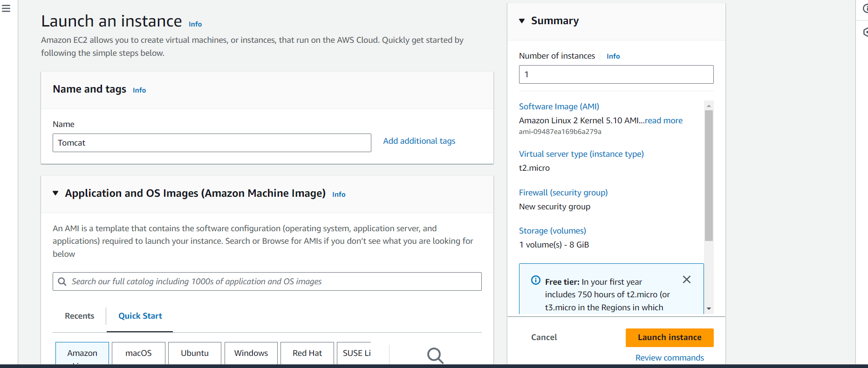  
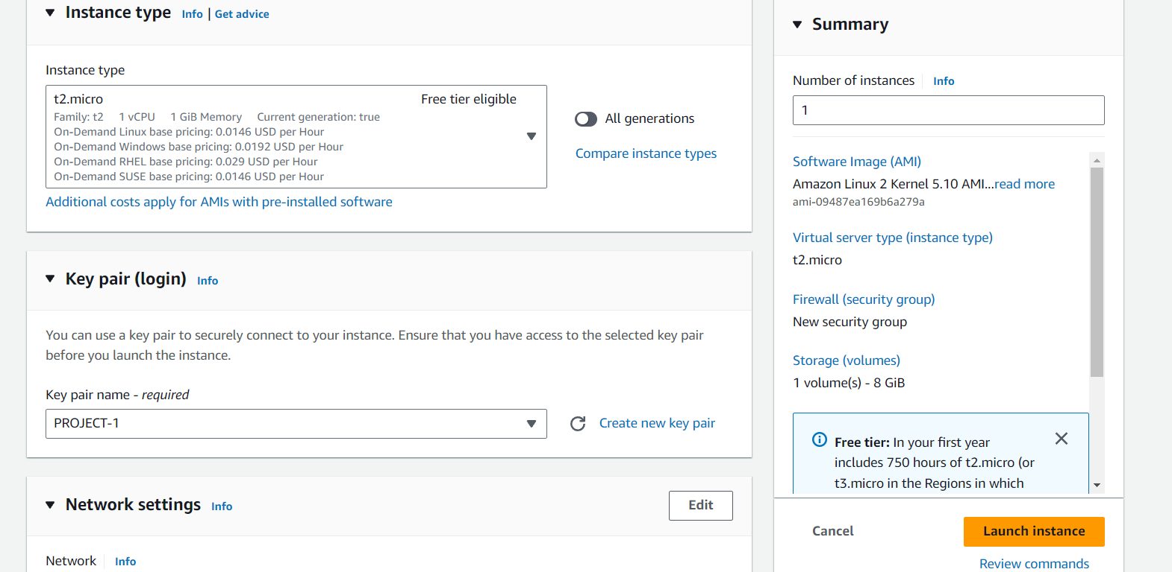**

**Installing Java:  
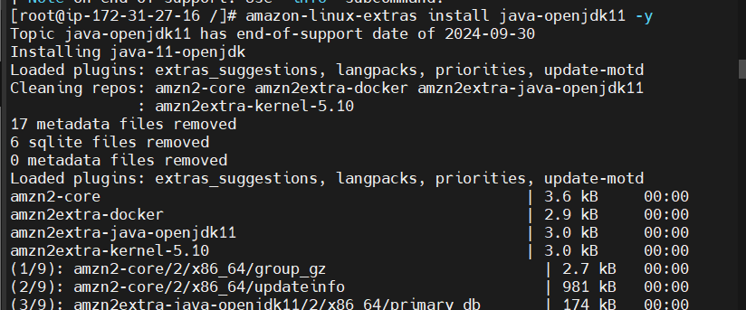  
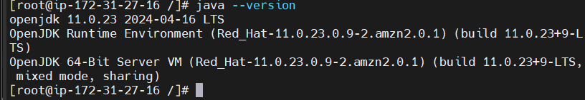  
Tomcat Installation:  
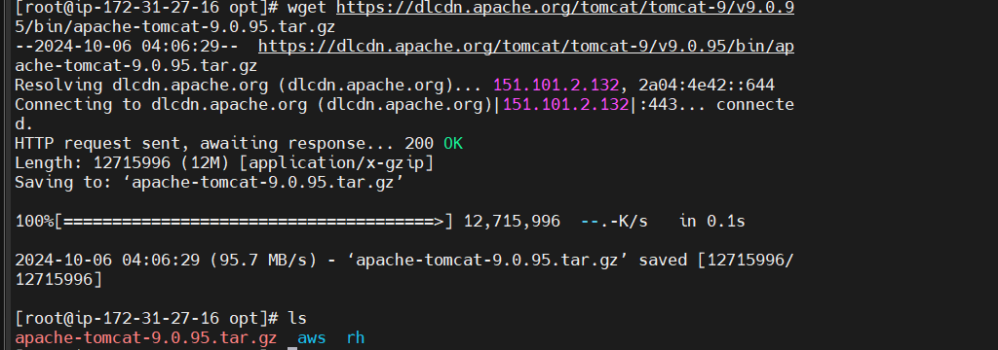  
Extract the TomCat Package:  
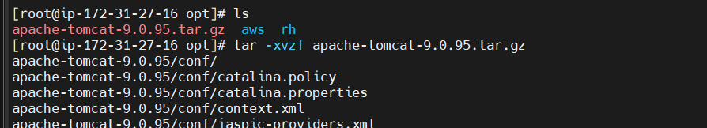  
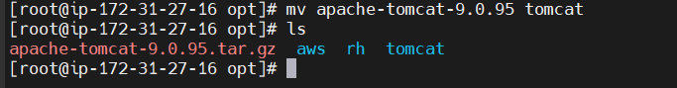**

**Starting The Tomcat:  
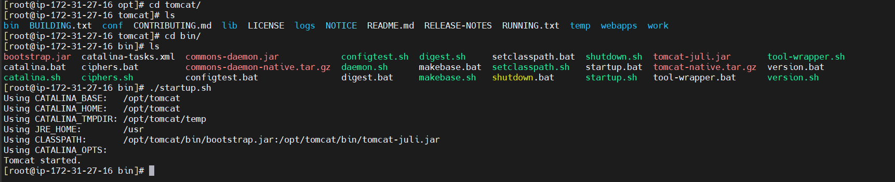  
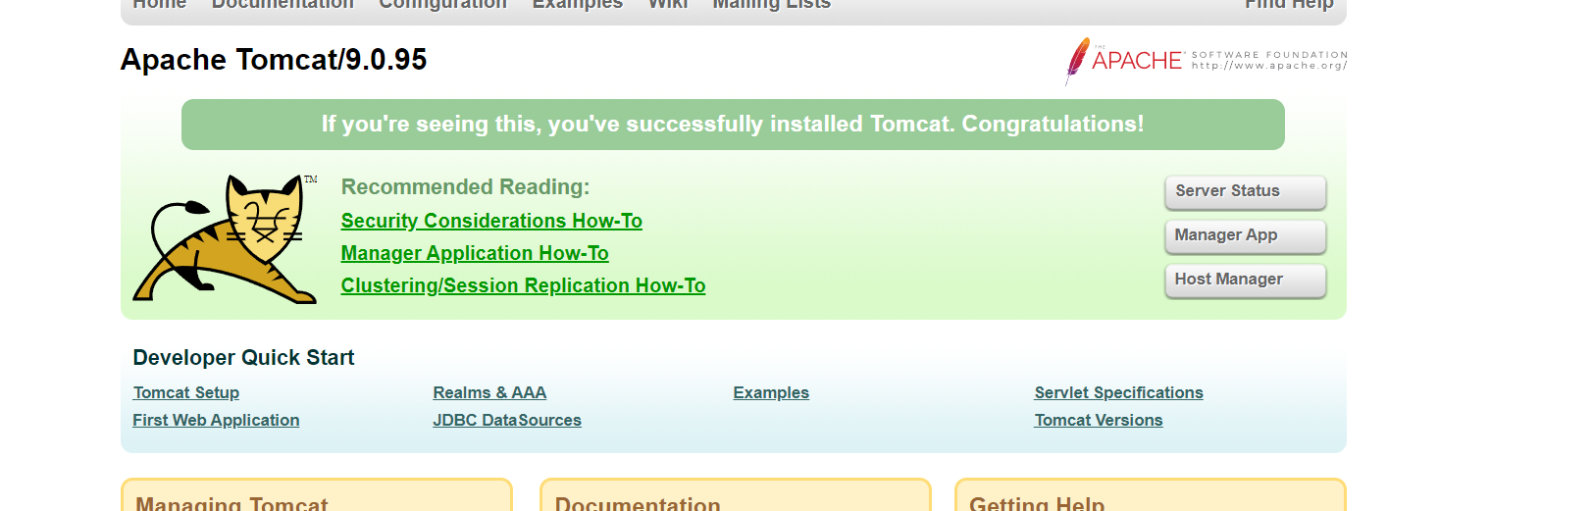  
Getting 403 status Error :  
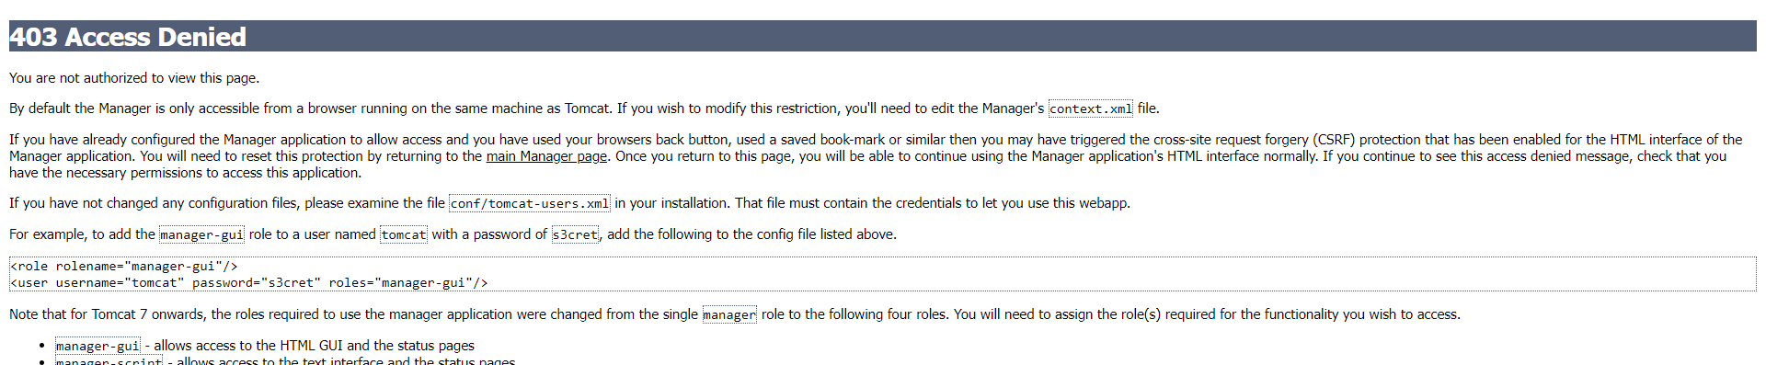  
For this one editing the context.xml file:  
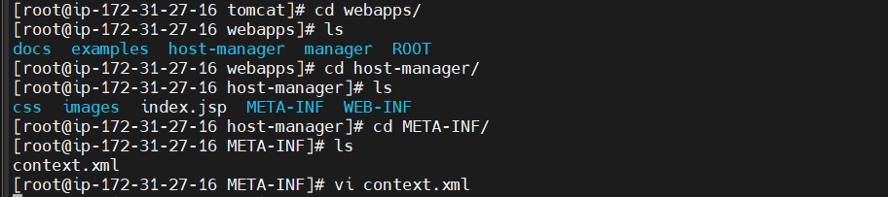  
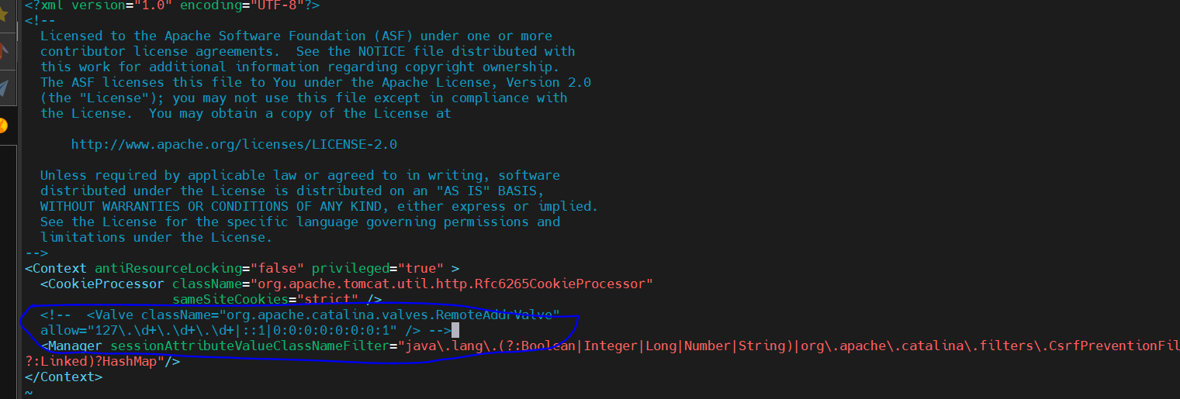**

**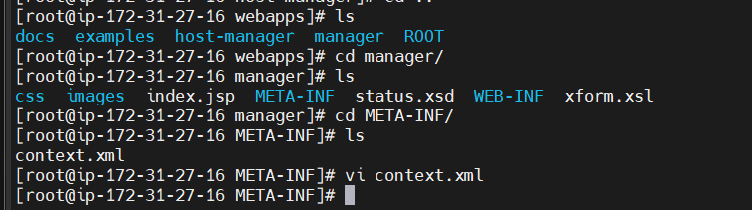  
Shutdown and Restarting Tomcat Server:  
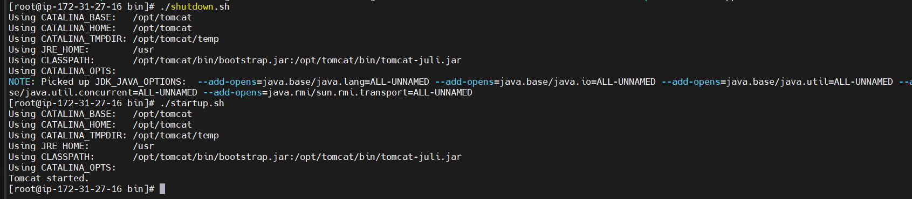  
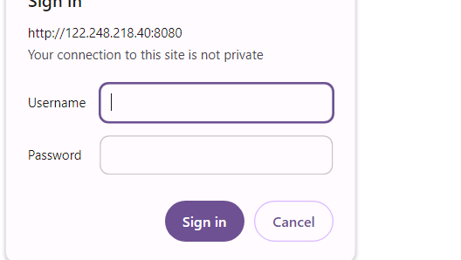  
Updating the tomcat-users.xml file:  
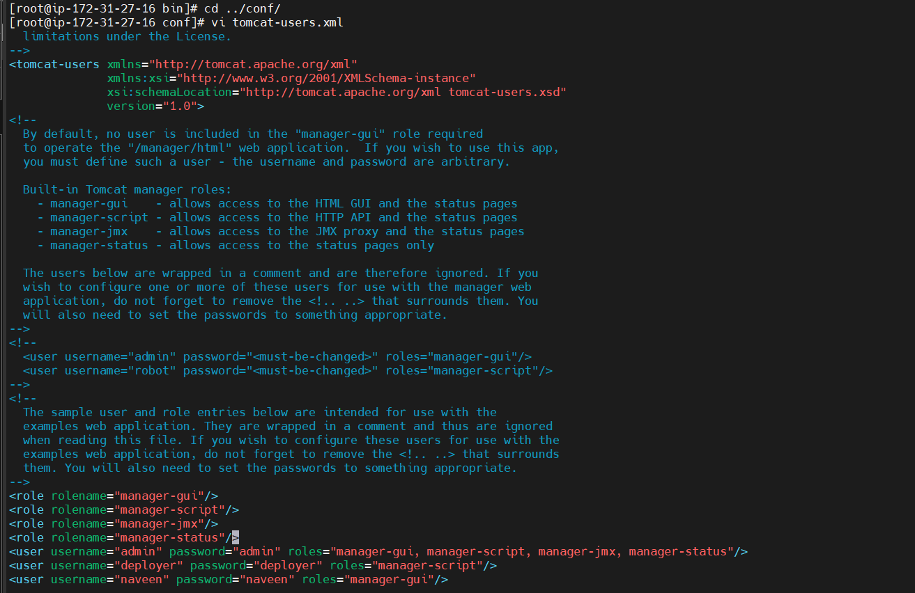  
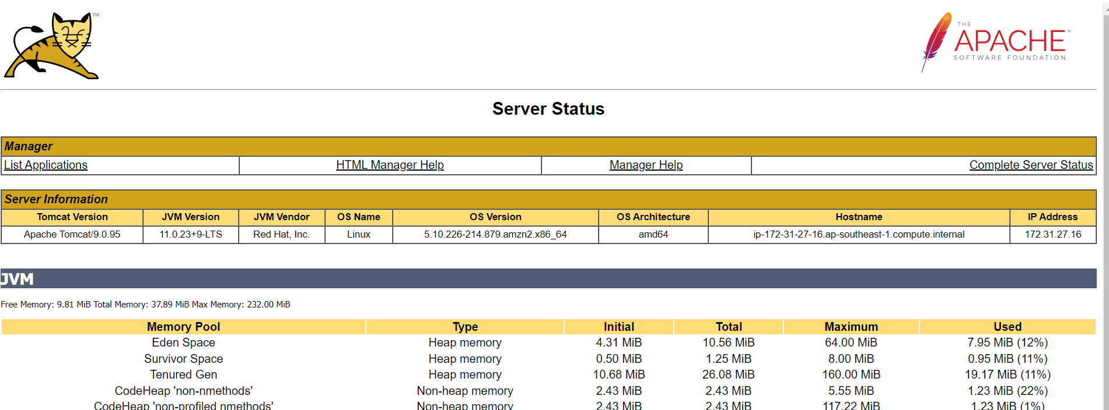  
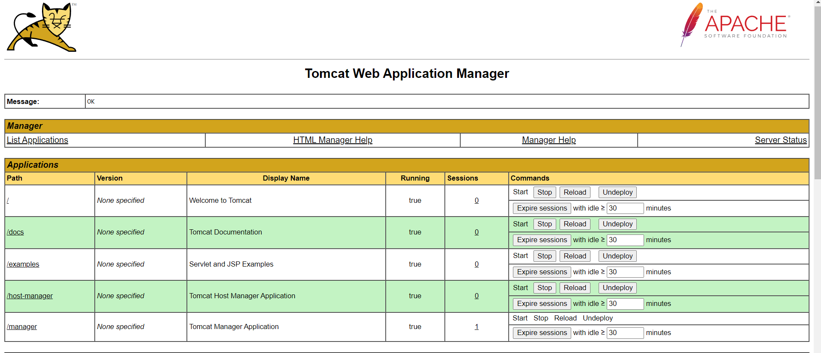  
Integrate Tomcat With Jenkins:** Installing Deploy To Container Plugin:  
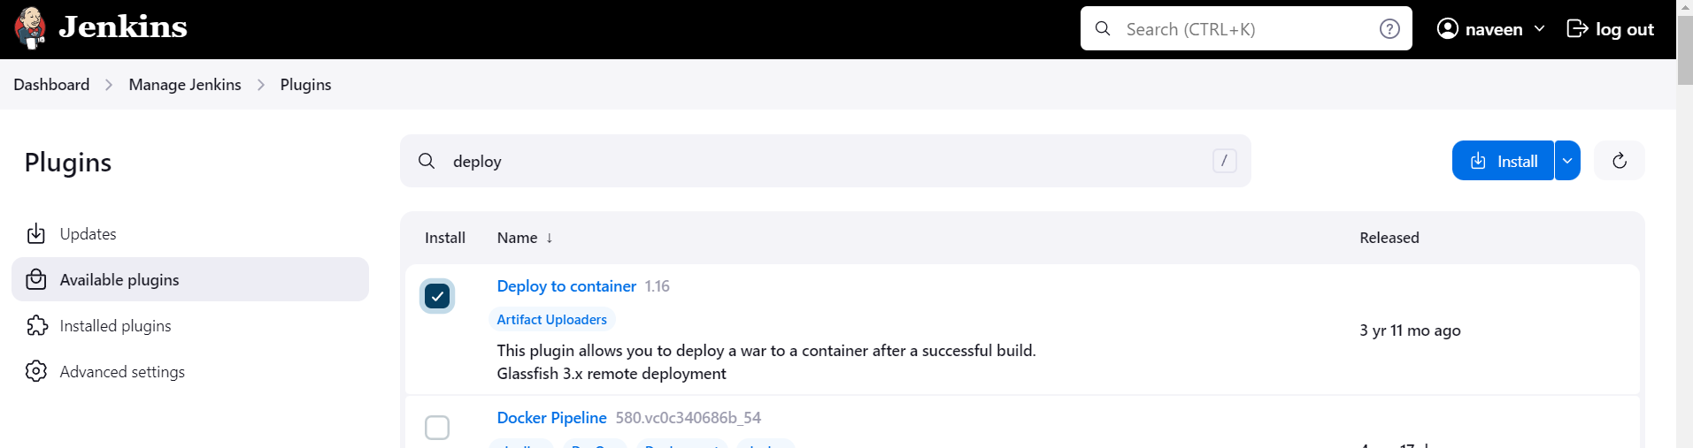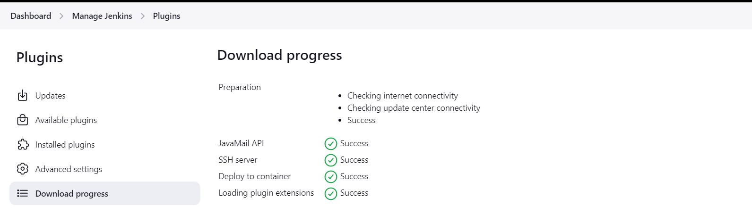

Configuring Tomcat Credentials:  
  
  
  
Building and deploying on the Tomcat server:

**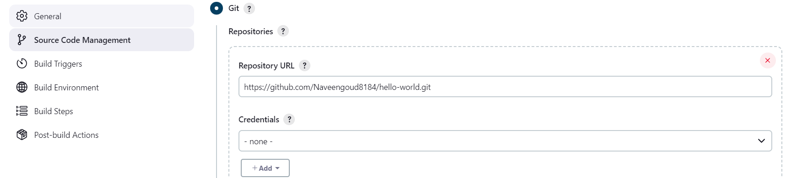  
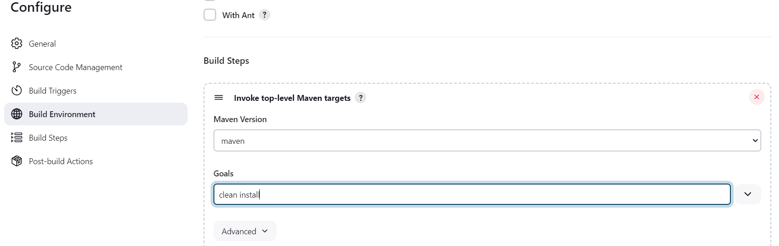  
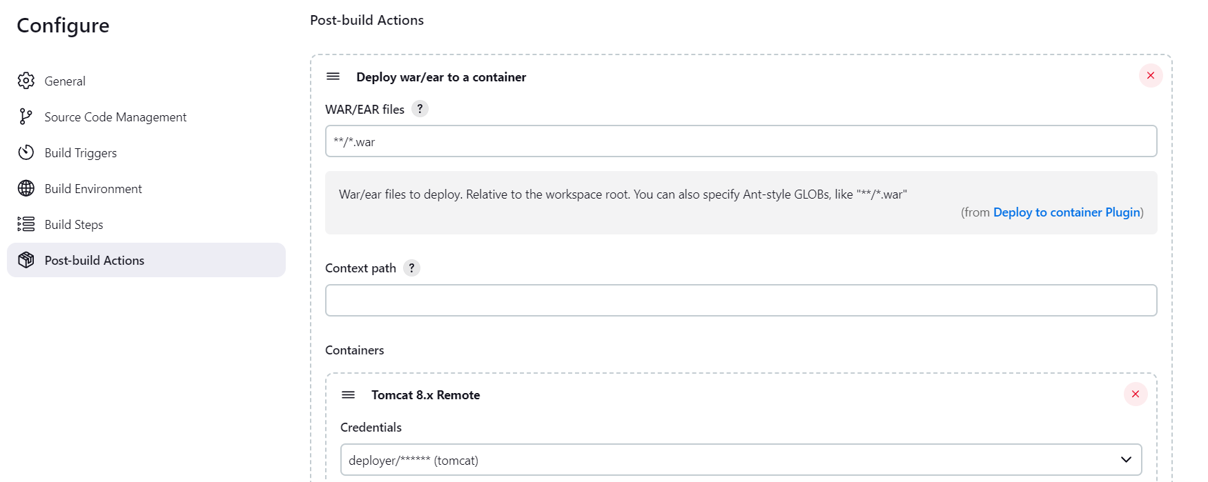  
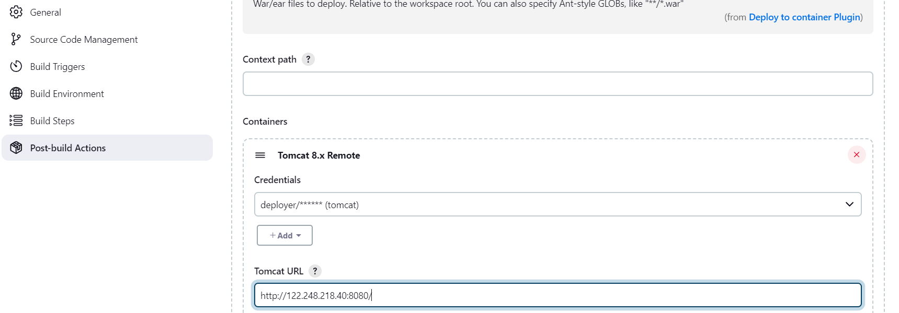  
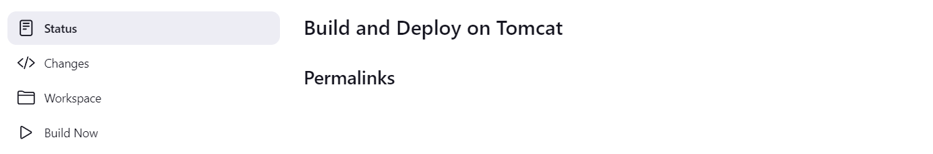  
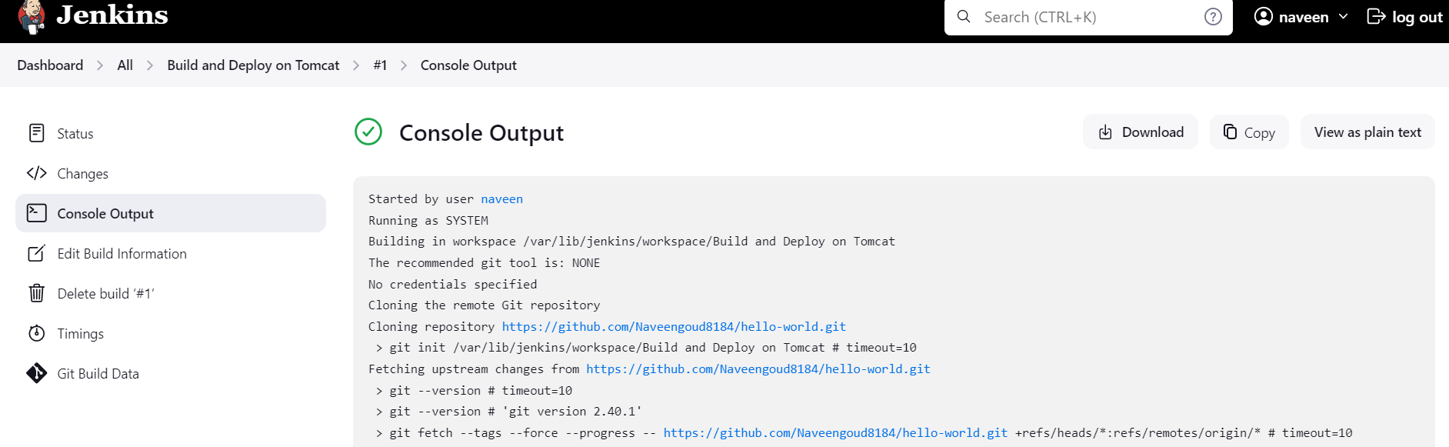  
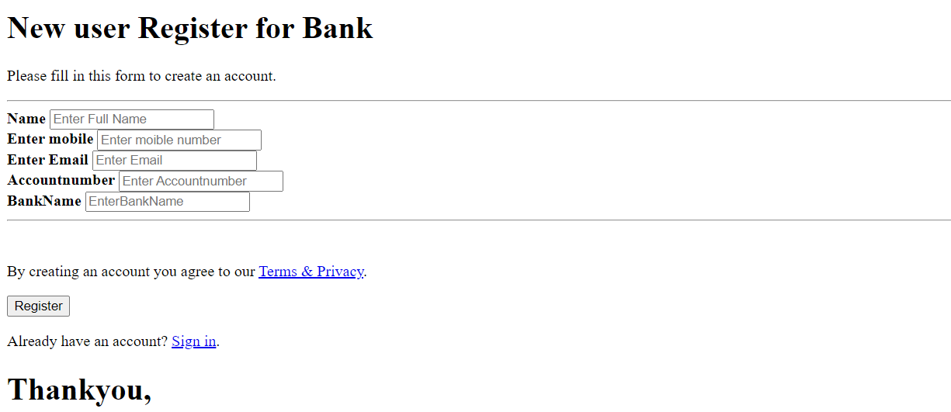**

**Deploy on Docker container:** Set up Docker Environment:  
 Launching Ec2 Instance:   
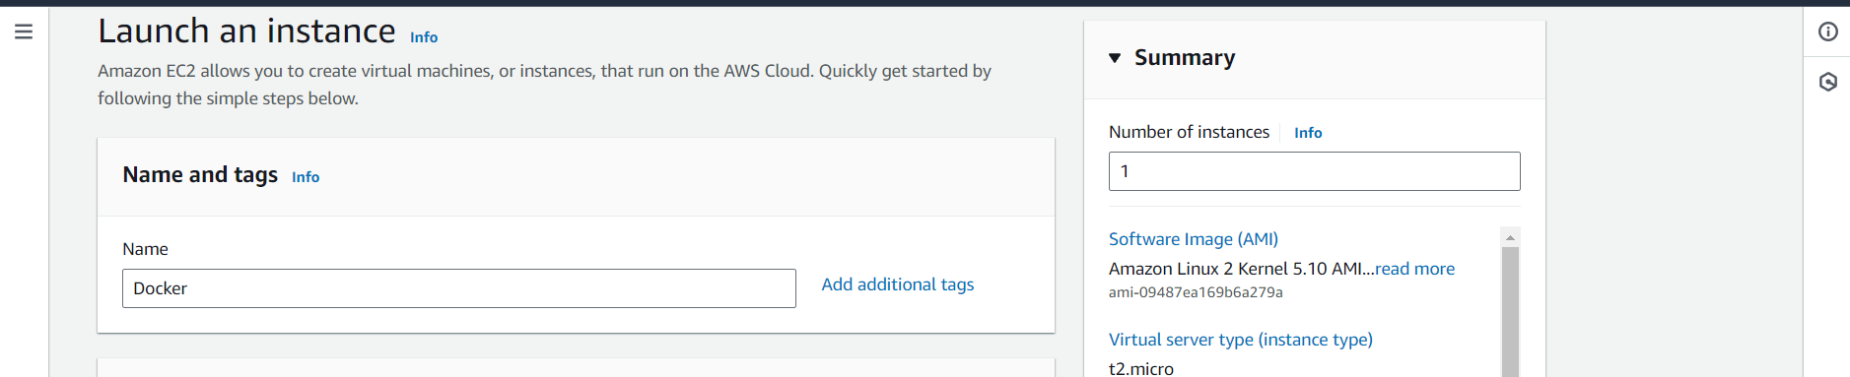  
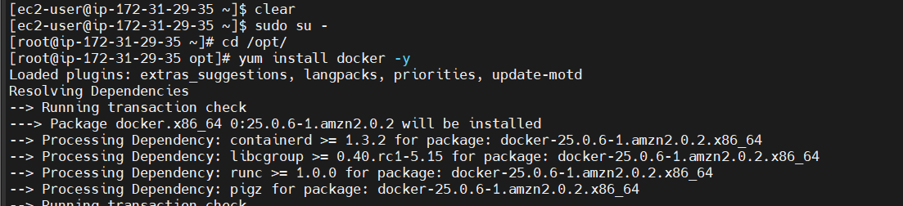  
  
 **Integrate Docker with Jenkins:** Installing publish over ssh plugin:

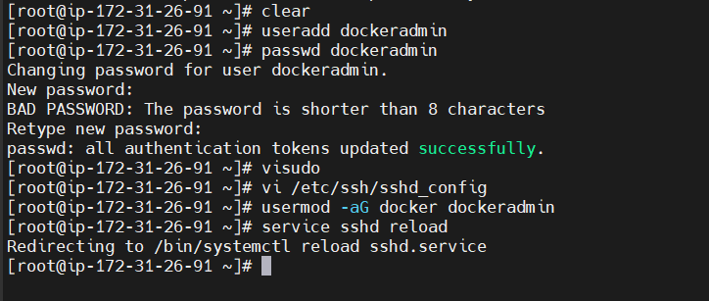  
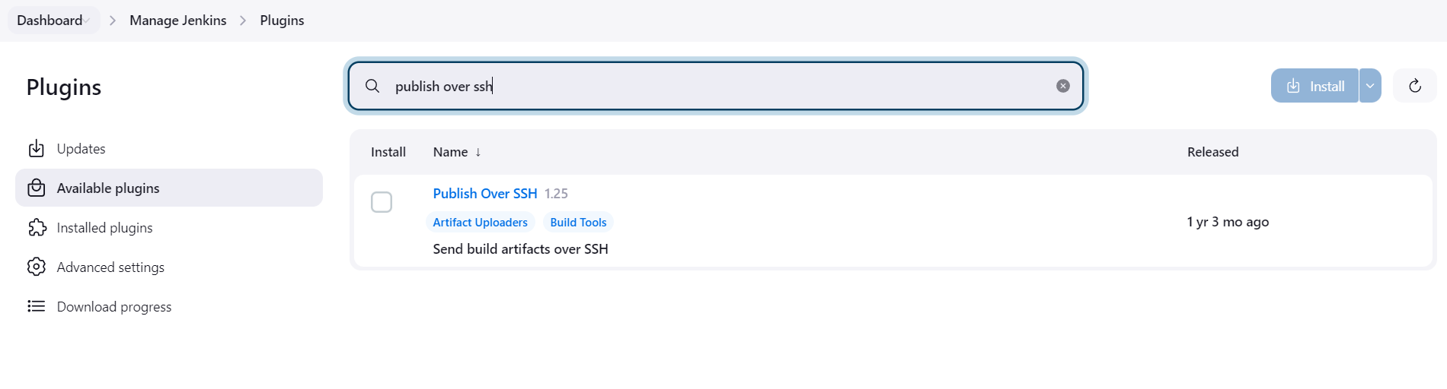

Configuring docker host in to jenkins:

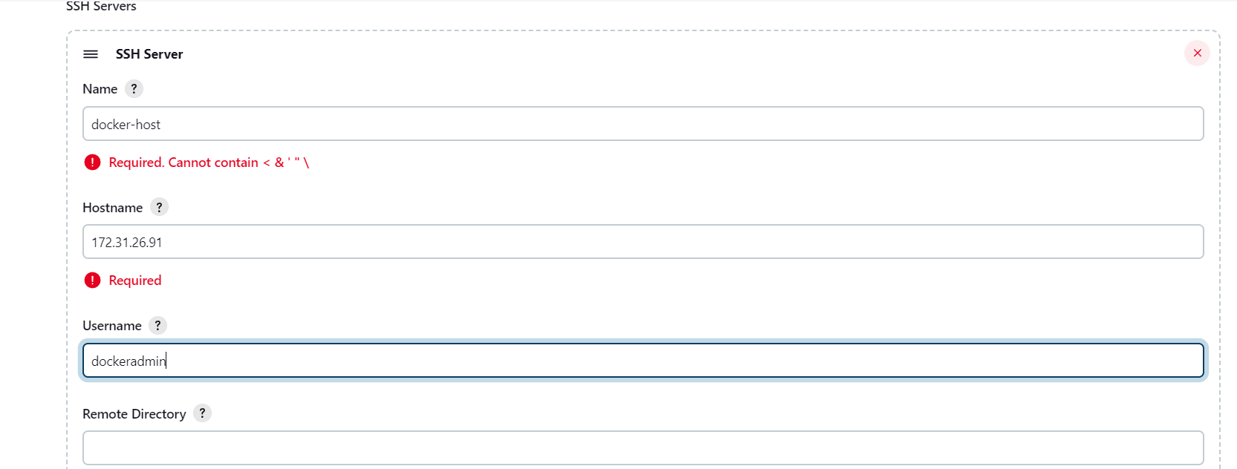  
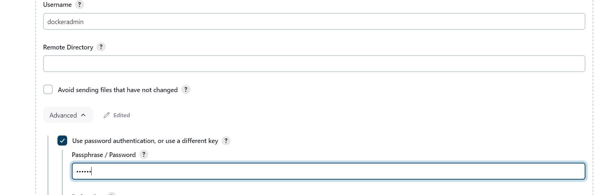

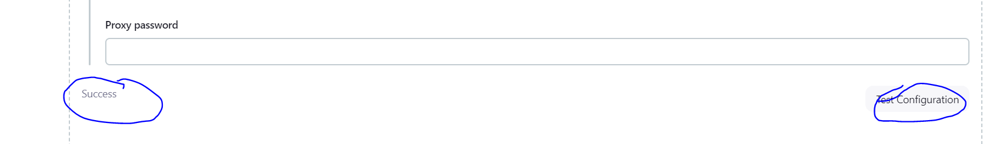 **Jenkins job to build and copy artifacts on the dockerhost:** Creating Jenkins job:  
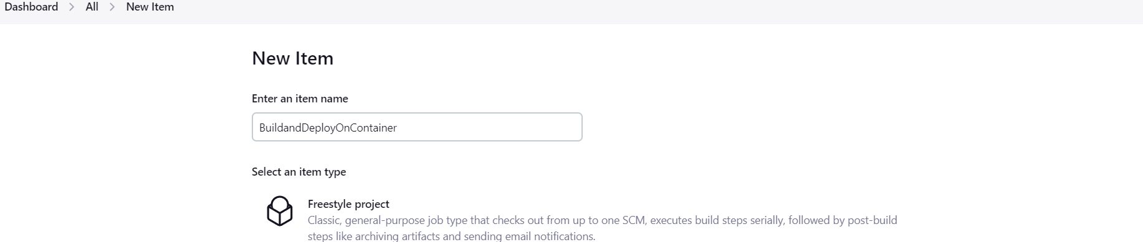  
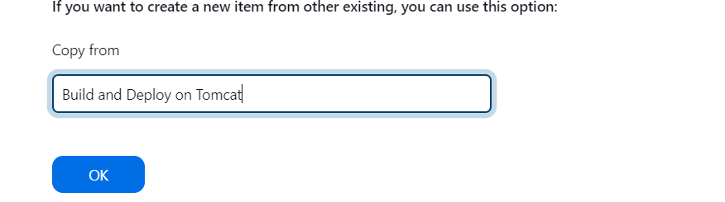  
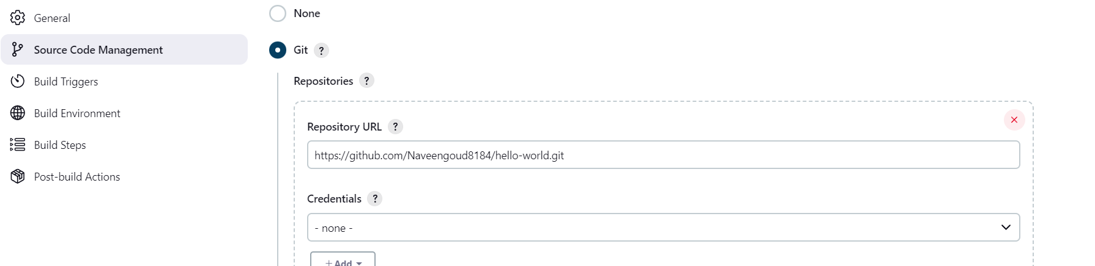  
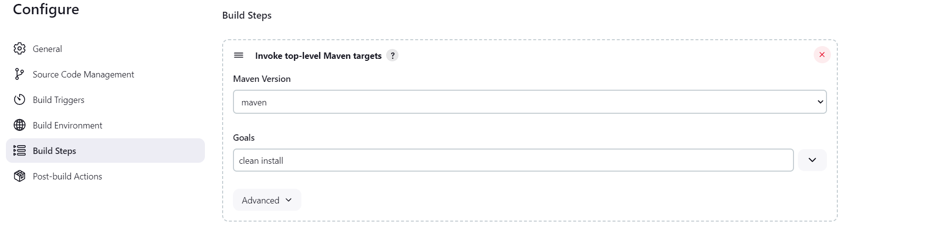  
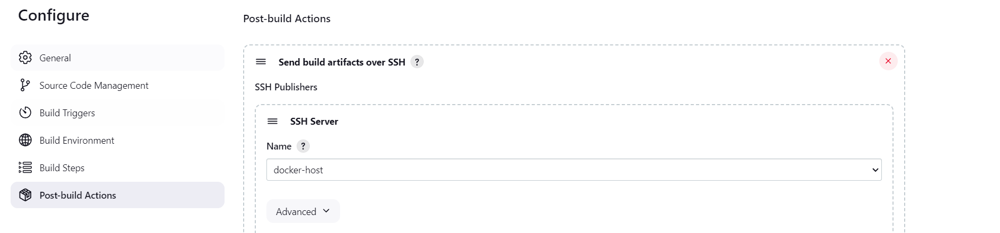

Setting up public over ssh plugin:

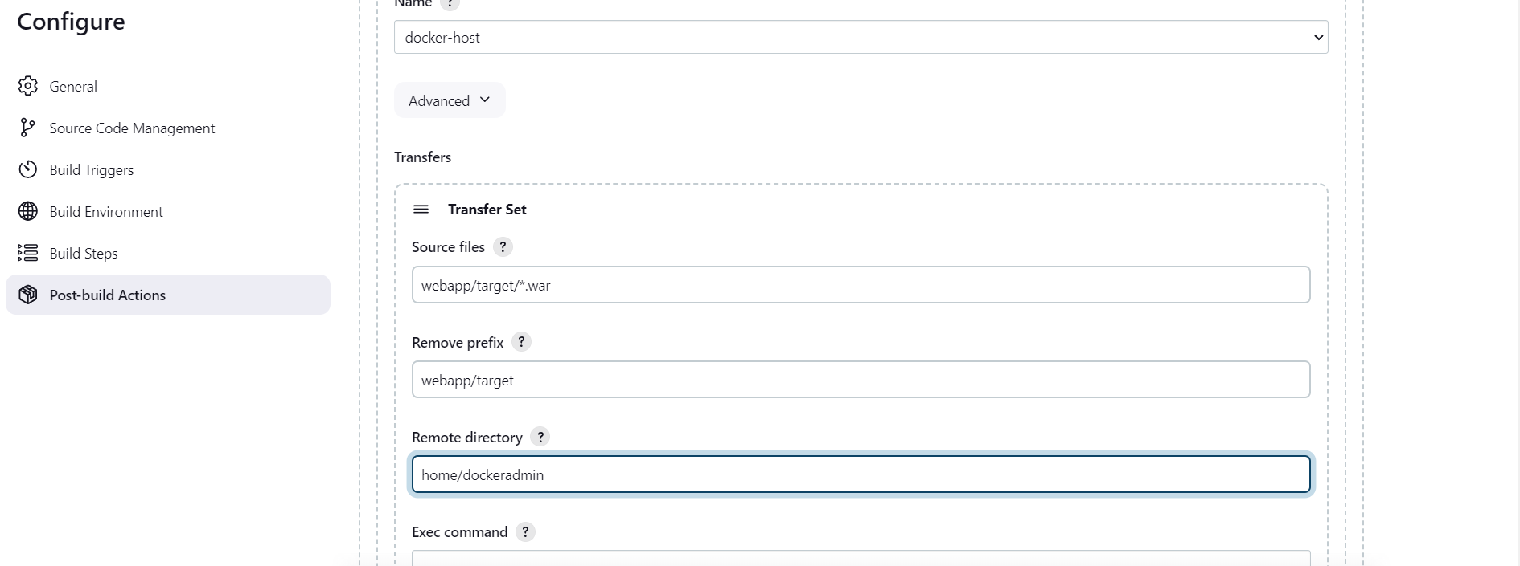

Using the WAR file to create Docker images and containers:  
  
Creating Docker directory:  
  
  
Changing the owner and groups permissions:  
  
  
  
Changing ssh servers remote directory:

**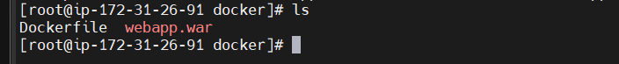  
Copy the war file into webapps:  
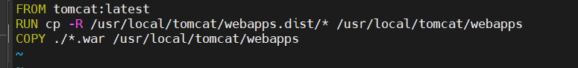  
Creating Docker Images:  
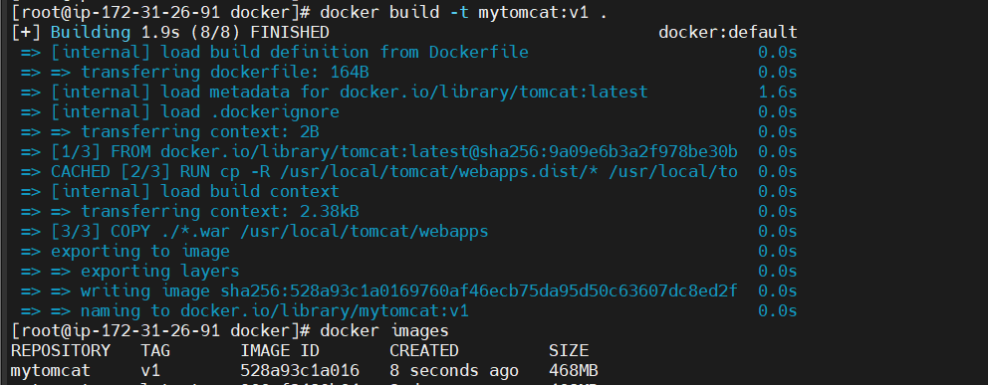  
Creating docker containers:**

Jenkins job to automate CI/CD, build, and deploy the application on Docker containers:  
 Updating exec command:

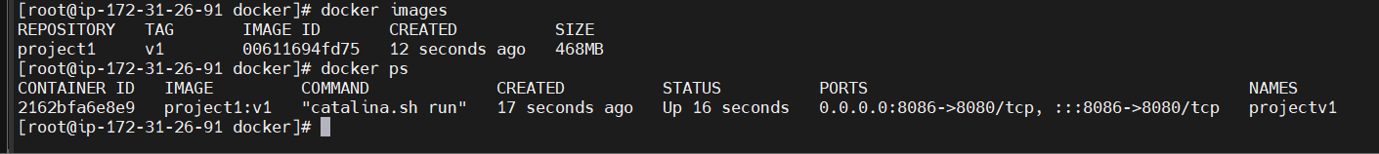

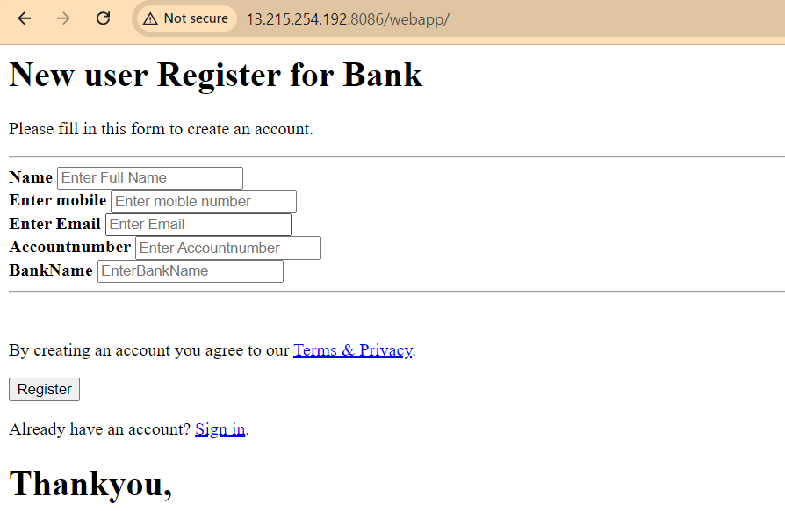

**Installing Ansible Server:**

**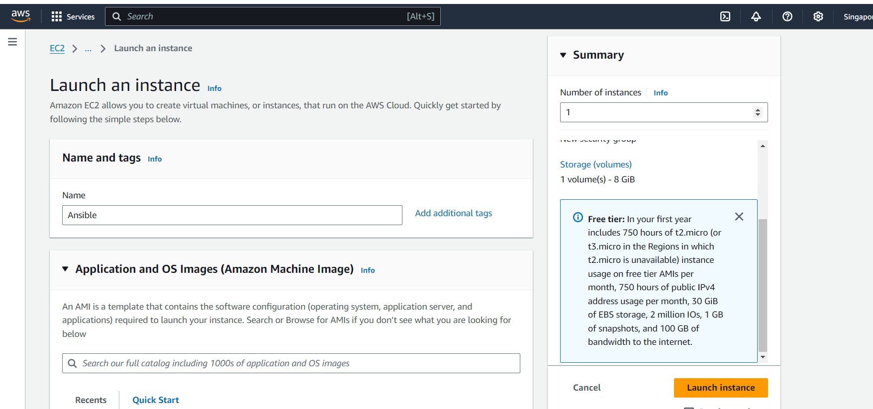  
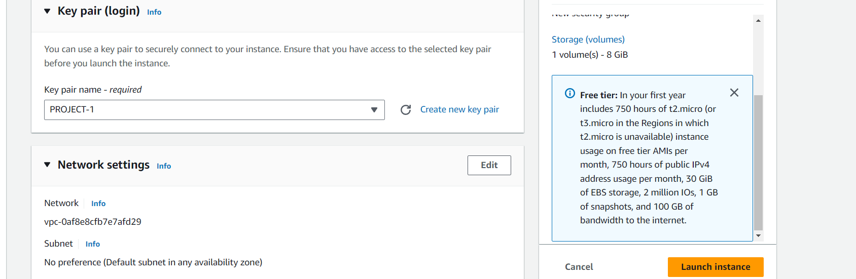  
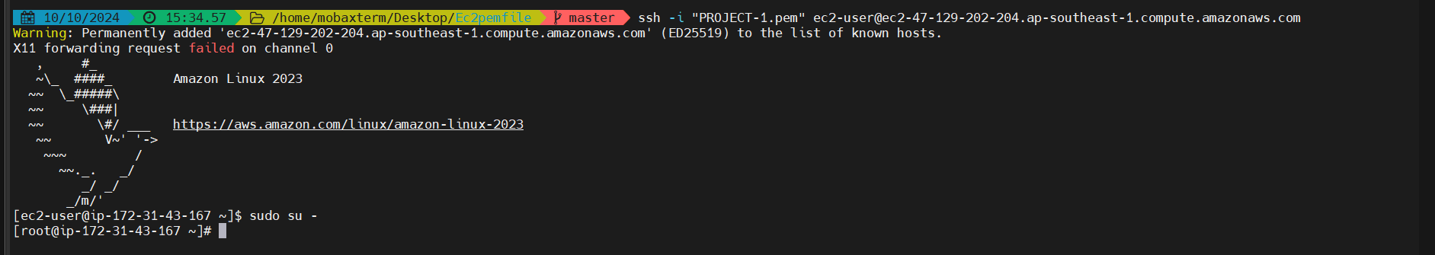**

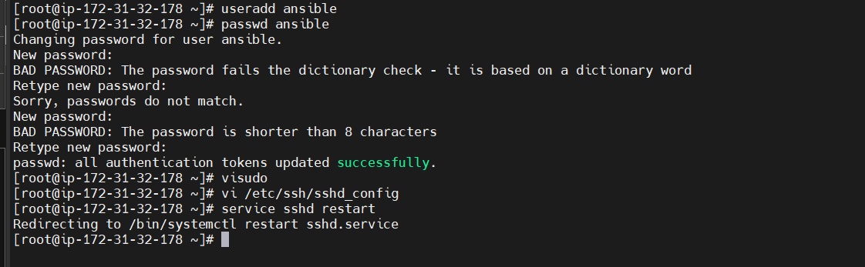

**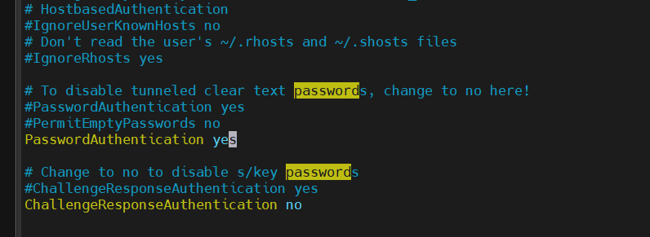  
log in to User:  
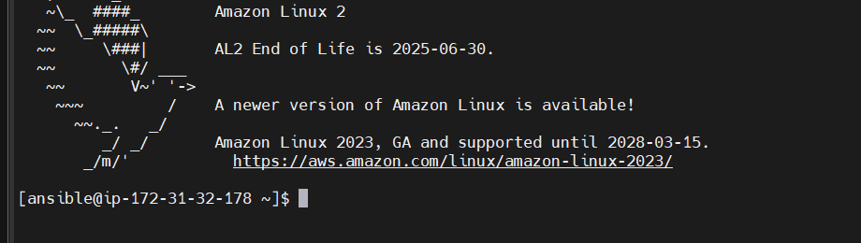  
Creating The ssh-keygen  
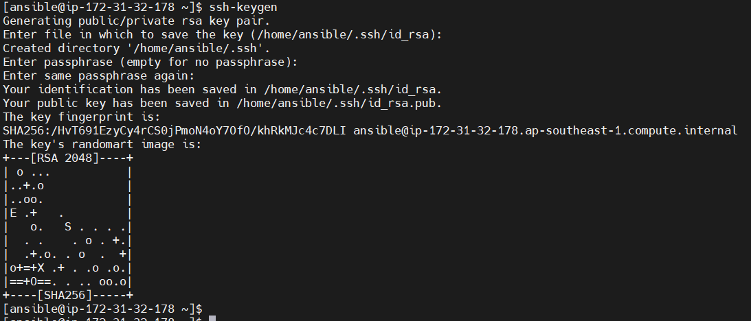**

**Installing Ansible:  
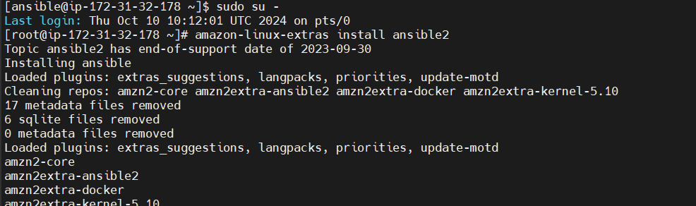  
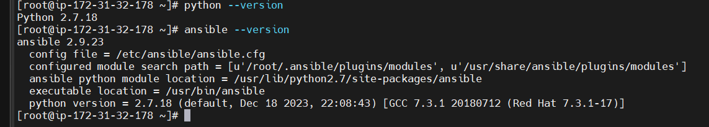  
Manage docker with Ansible Host:  
 Creating same user on docker:  
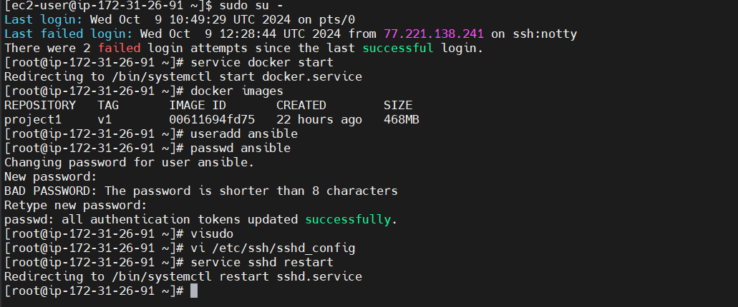**

**Configuring the Docker ip address in to Ansible Host:**

**  
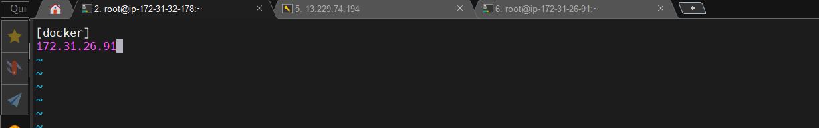**

**Ssh-keys:  
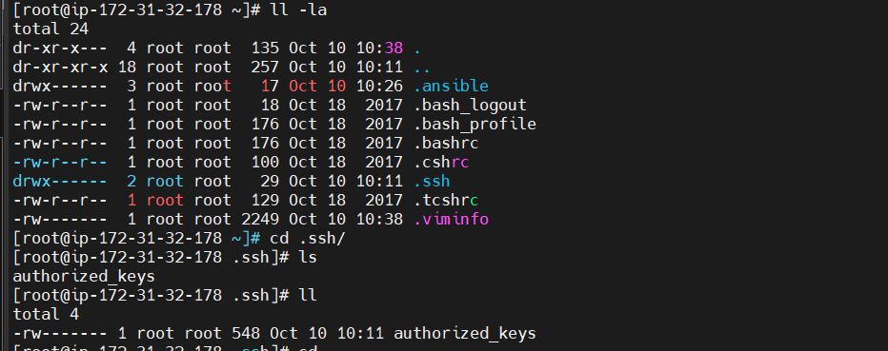  
Copy the ssh-keys Target host:  
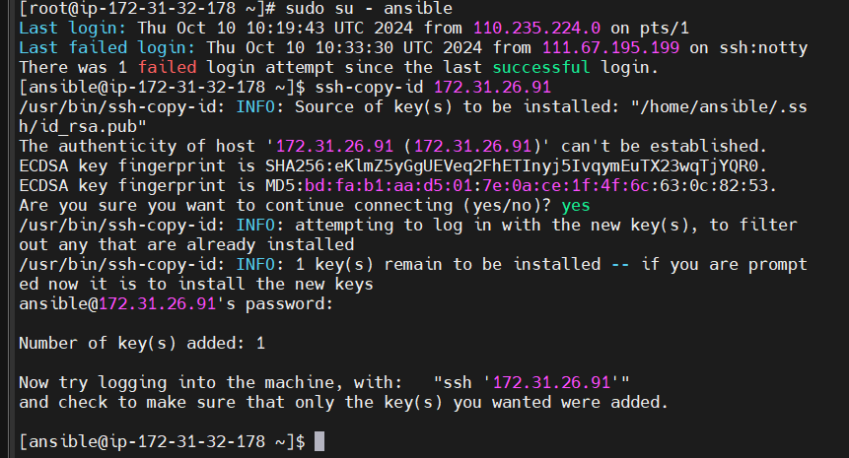  
On docker host:  
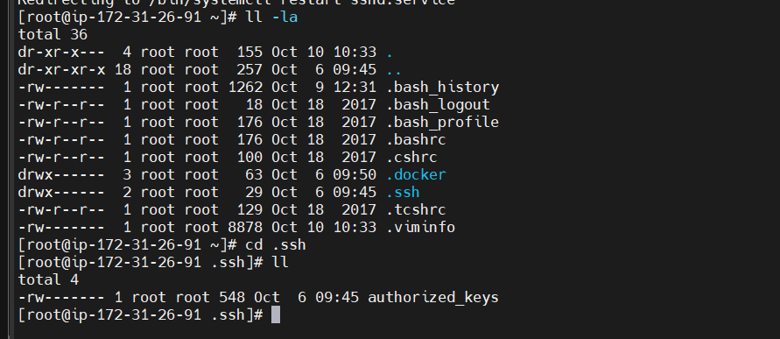**

Ansible server:  
  
Integrating Ansible with Jenkins:  
 Configuring jenkins to Ansible server:

**Creating the new job on jenkins:  
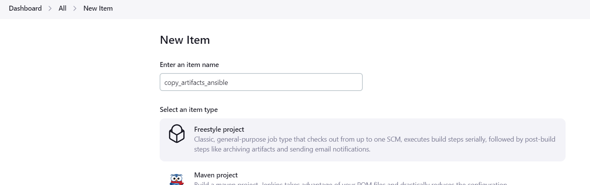  
Copy All configure data from previous job  
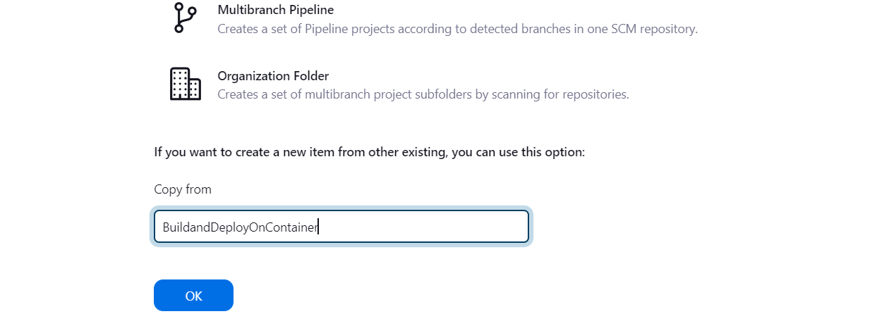  
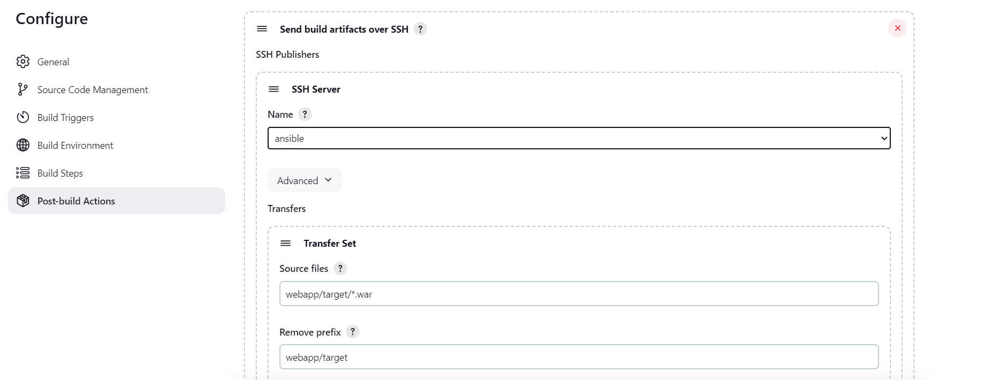  
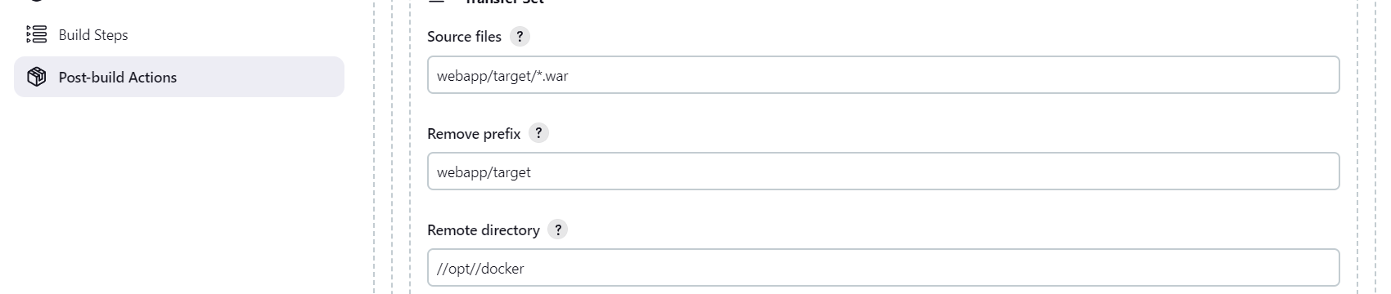  
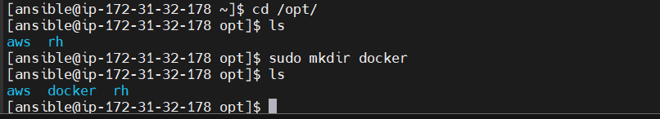  
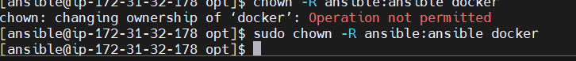  
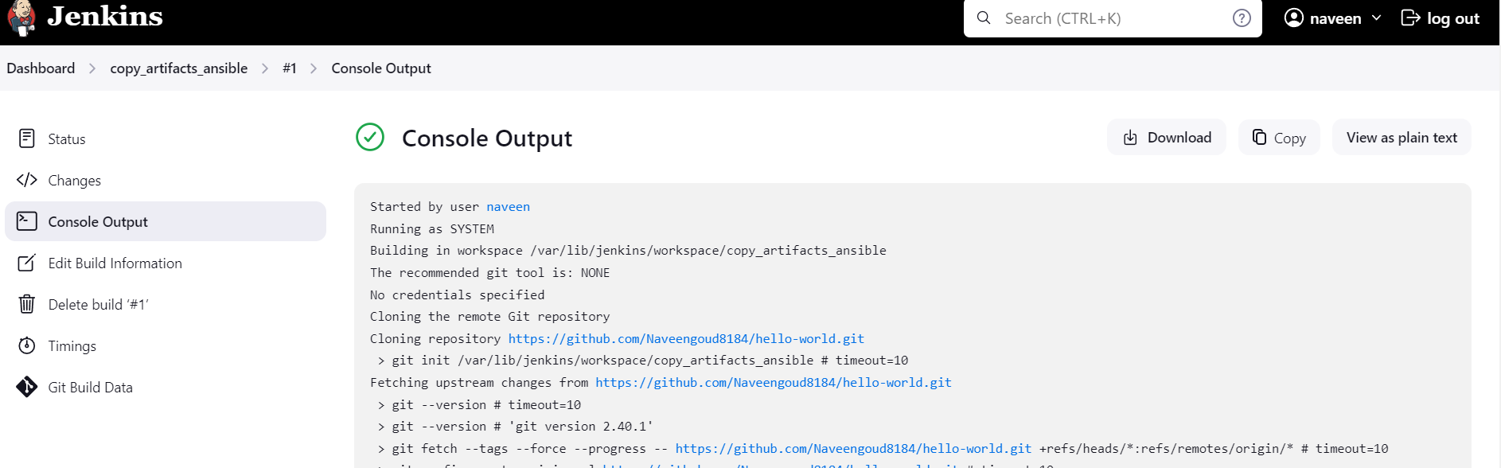  
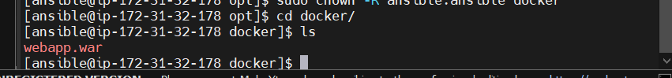  
Build Image and container on Ansible:  
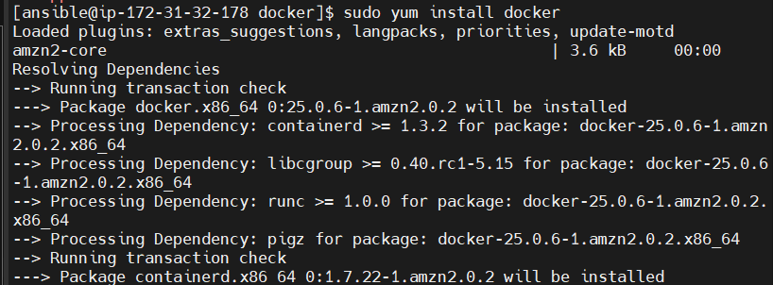  
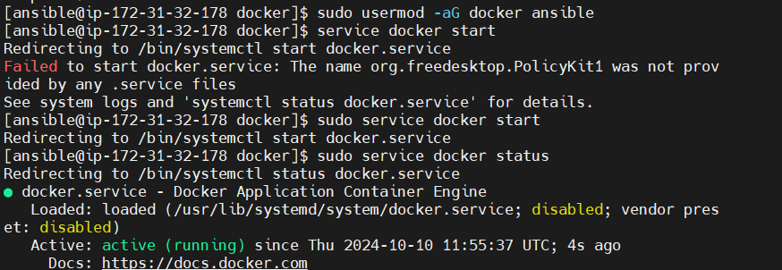**

Creating Dockerfile for the application:

**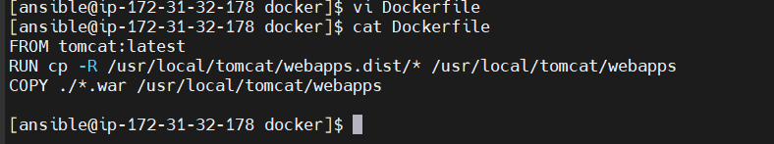  
Building the image:  
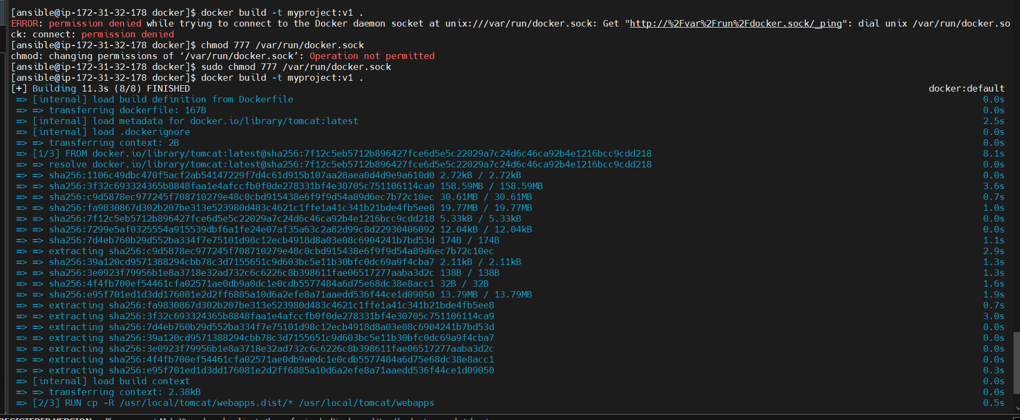  
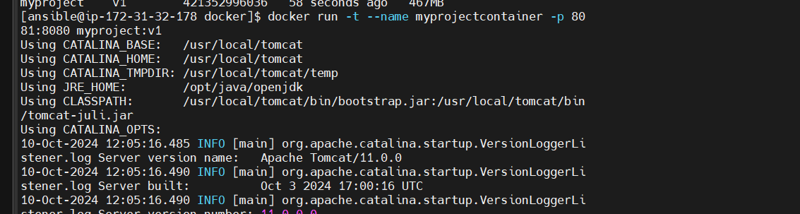  
  
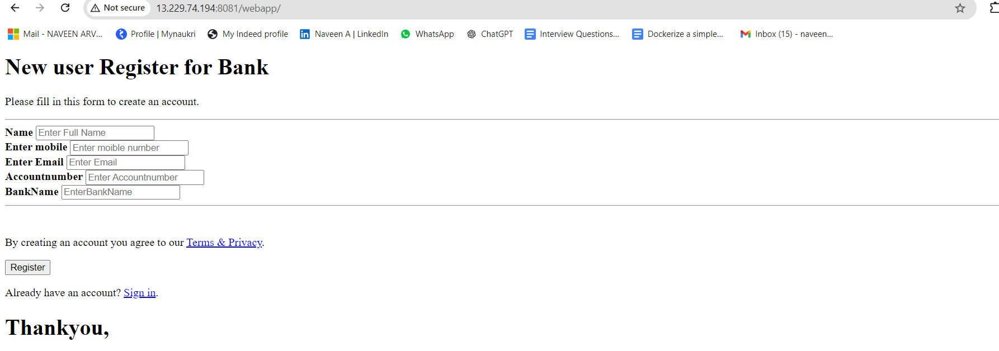**

**Creating Ansible Playbook:  
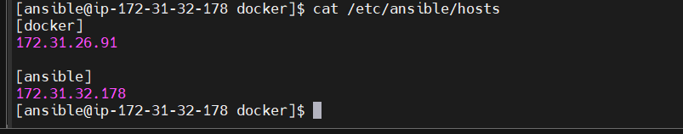**

**Config the ssh-keys:  
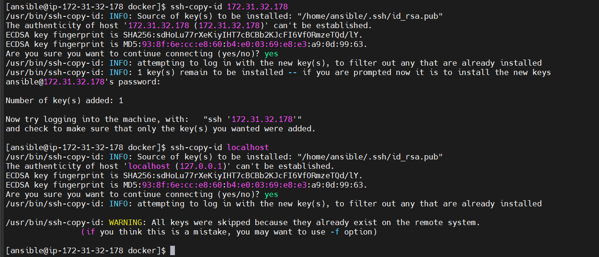  
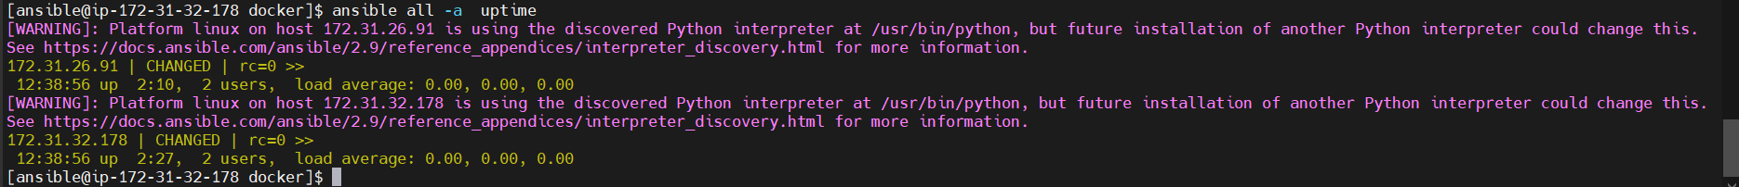  
Creating docker image using Ansible playbook:  
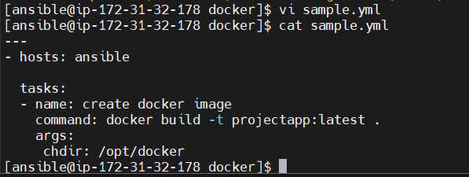**

**Ansible playbook:  
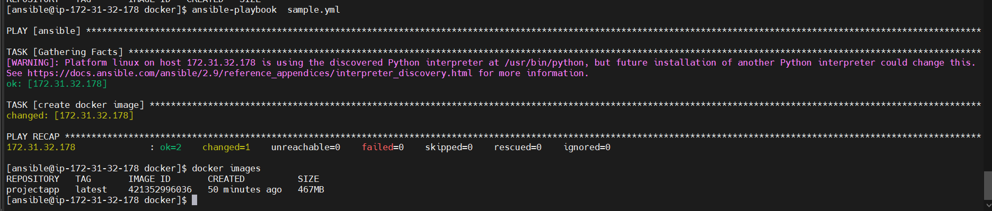**

**Copy the docker image to dockerhub using Ansible playbook:  
 Login to the Docker hub:  
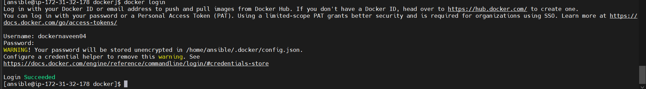  
Push to DockerHub:**

Jenkins job to build an imageand push to DockerHub on to Ansible:  
  
  
  
  
  
Jenkins job to create image and a container on docker host using Ansible Playbook:  
  
  
Before starting the Jenkins job on the Docker host:

**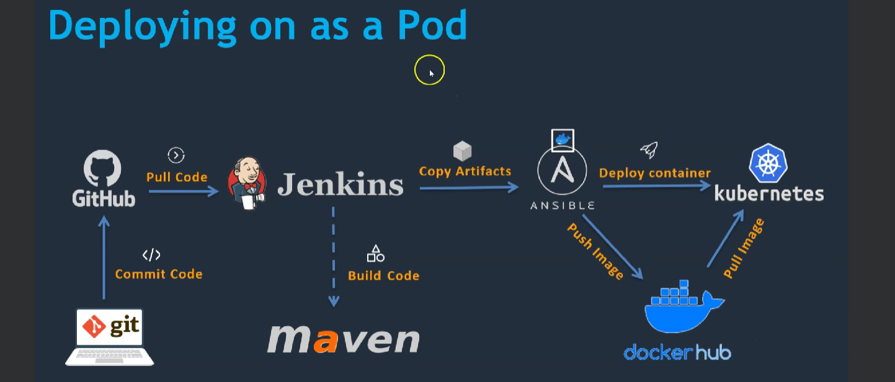  
Kubernetes Installation SetUp:  
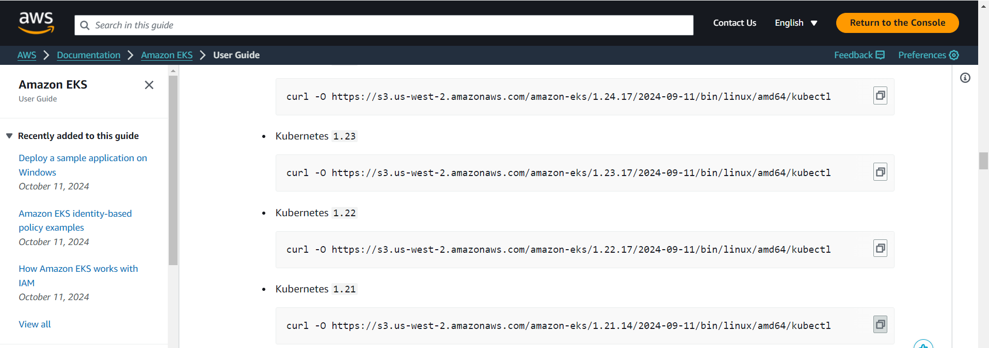  
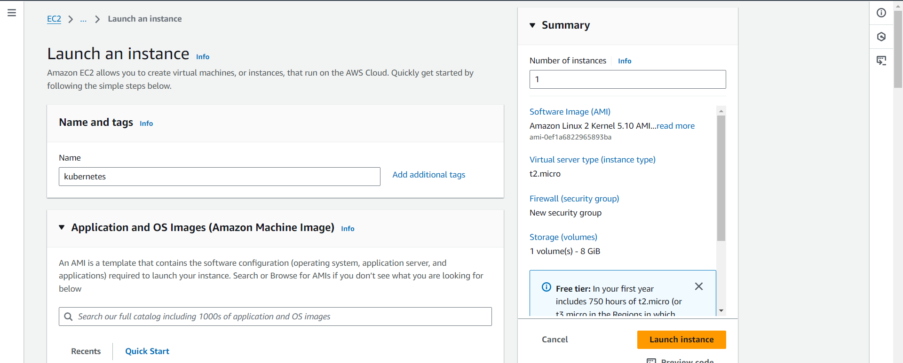**

**Installing AWS Cli:  
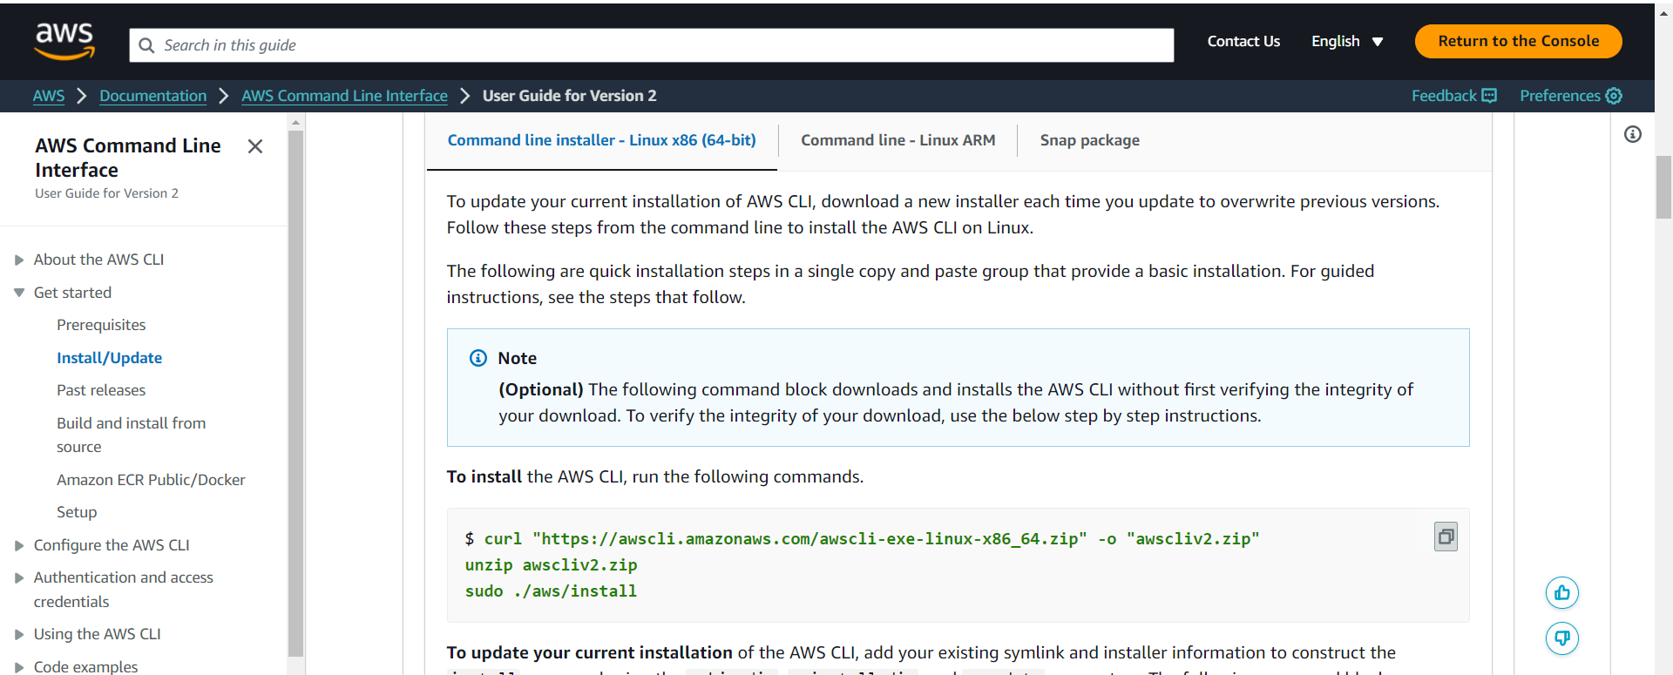  
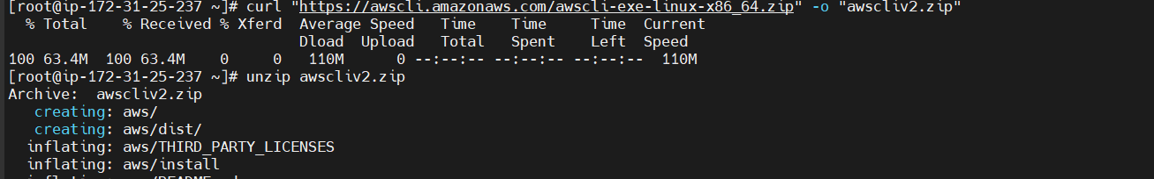  
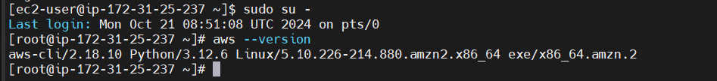  
Installing Kubectl:  
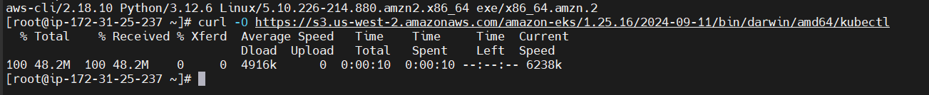**

**Installing Kubectl:  
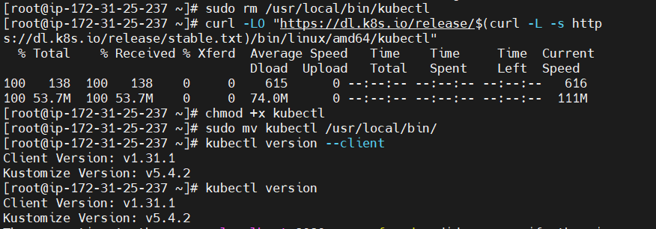  
  
  
  
  
Installing eksctl:  
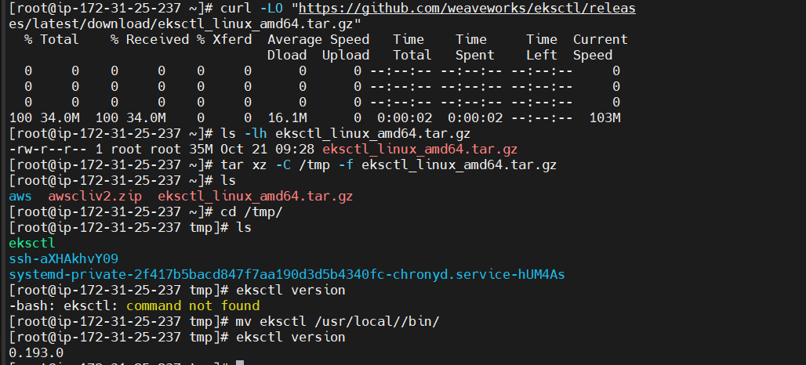  
IAM ROLES PERMISSIONS:  
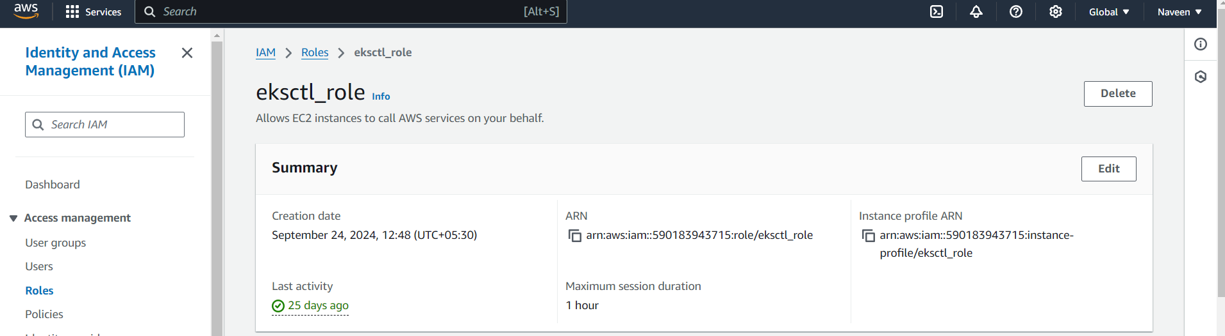  
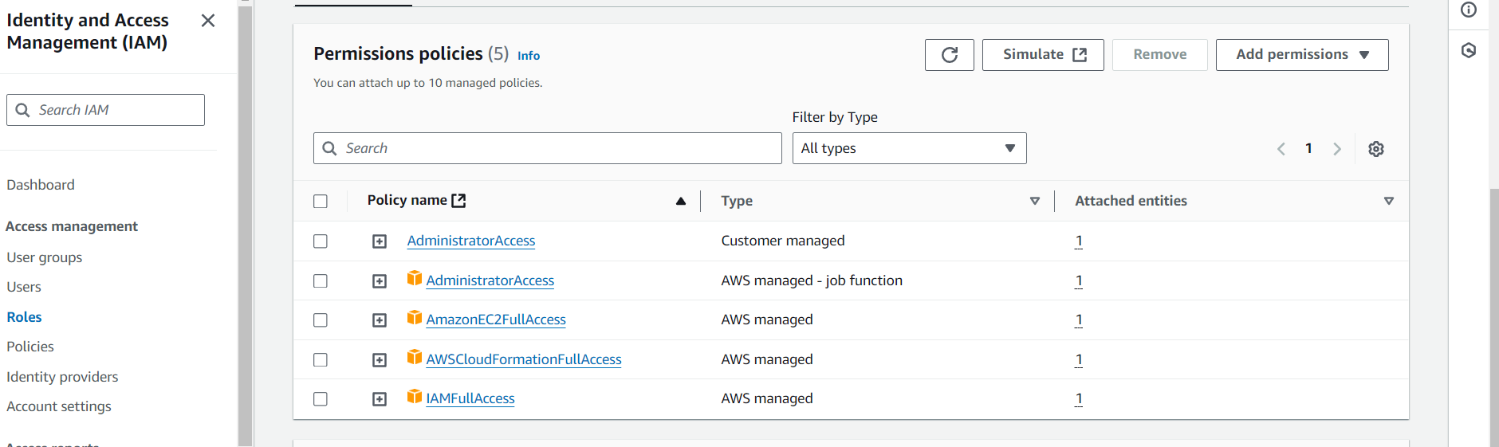  
Attaching Role to Instance:  
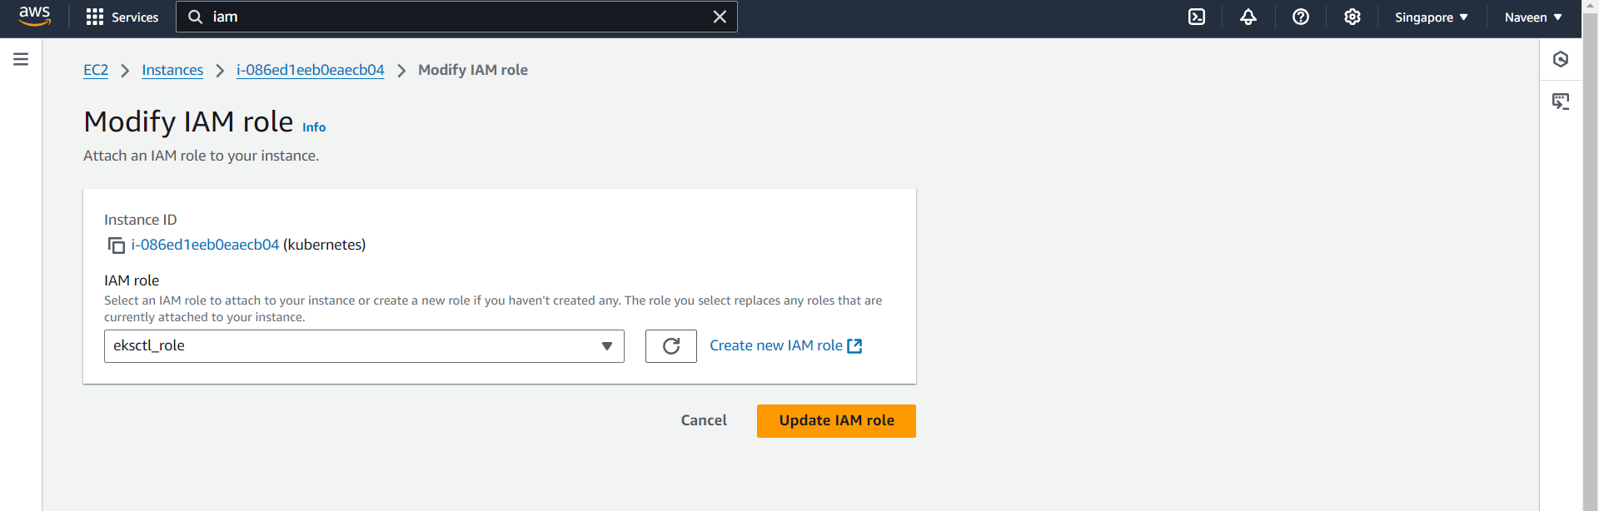**

**Creating the Cluster and Nodes:  
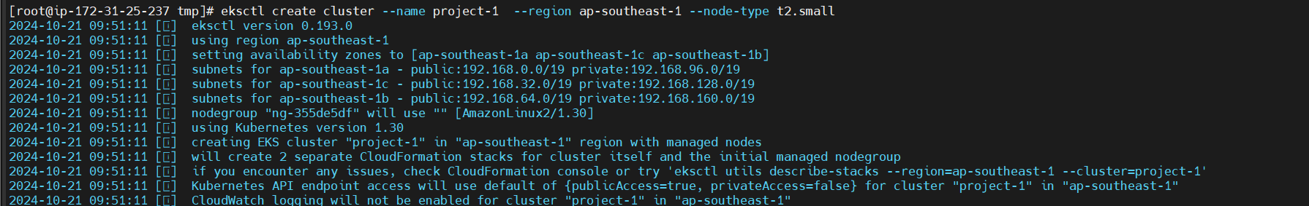  
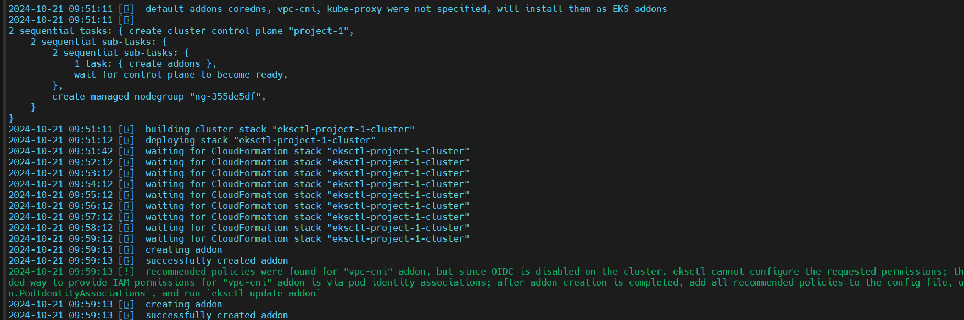  
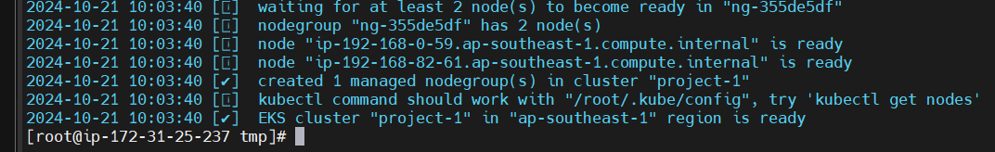  
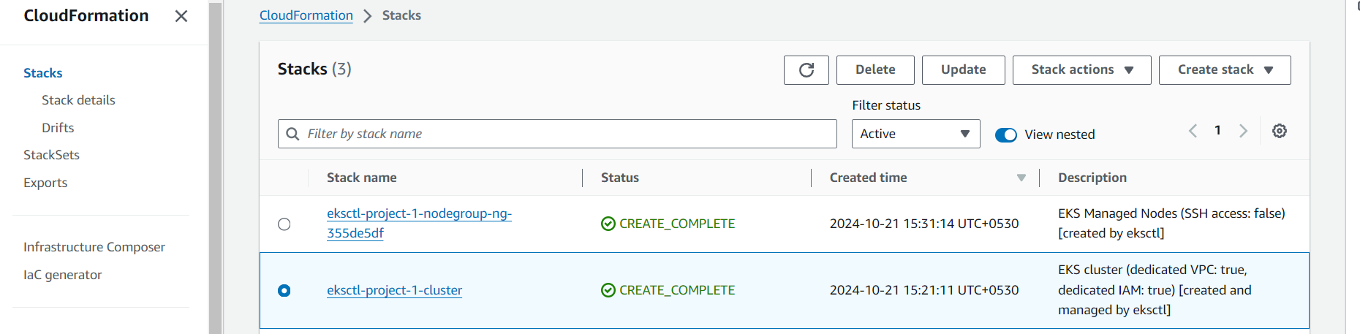  
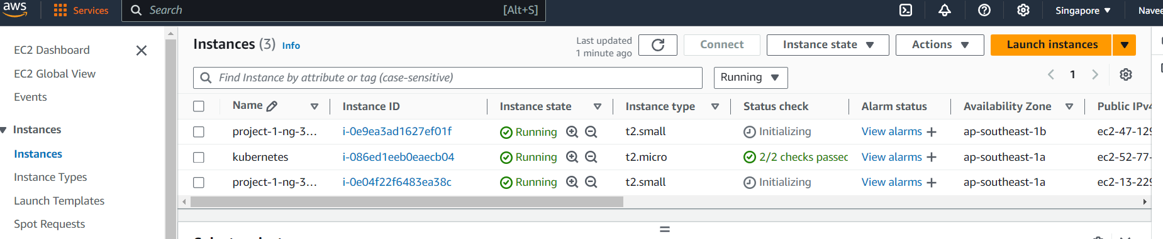  
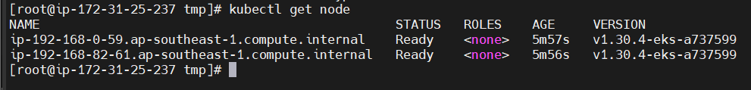**

**Creating Deployment manifest file:  
  
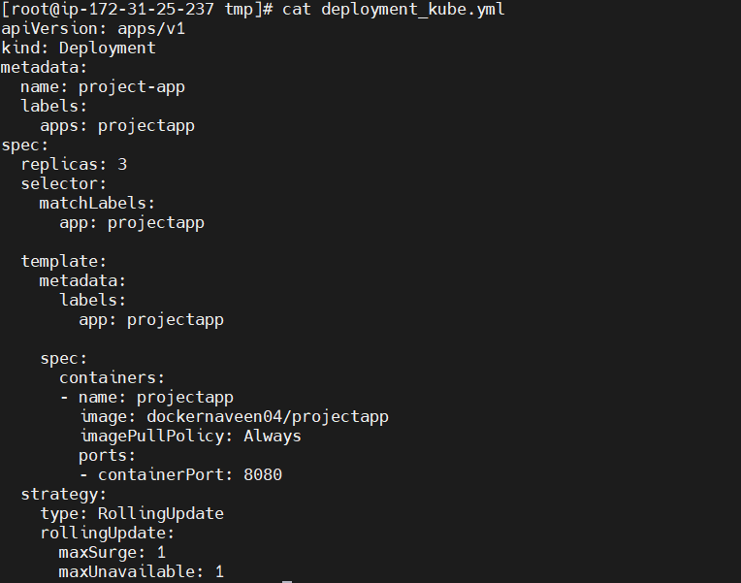  
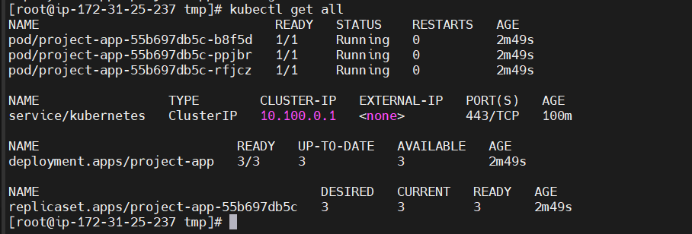  
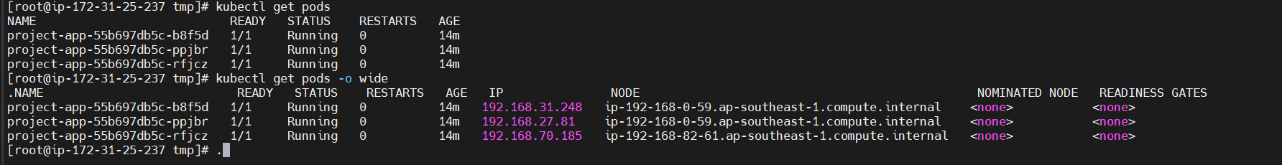**

**Creating service:  
  
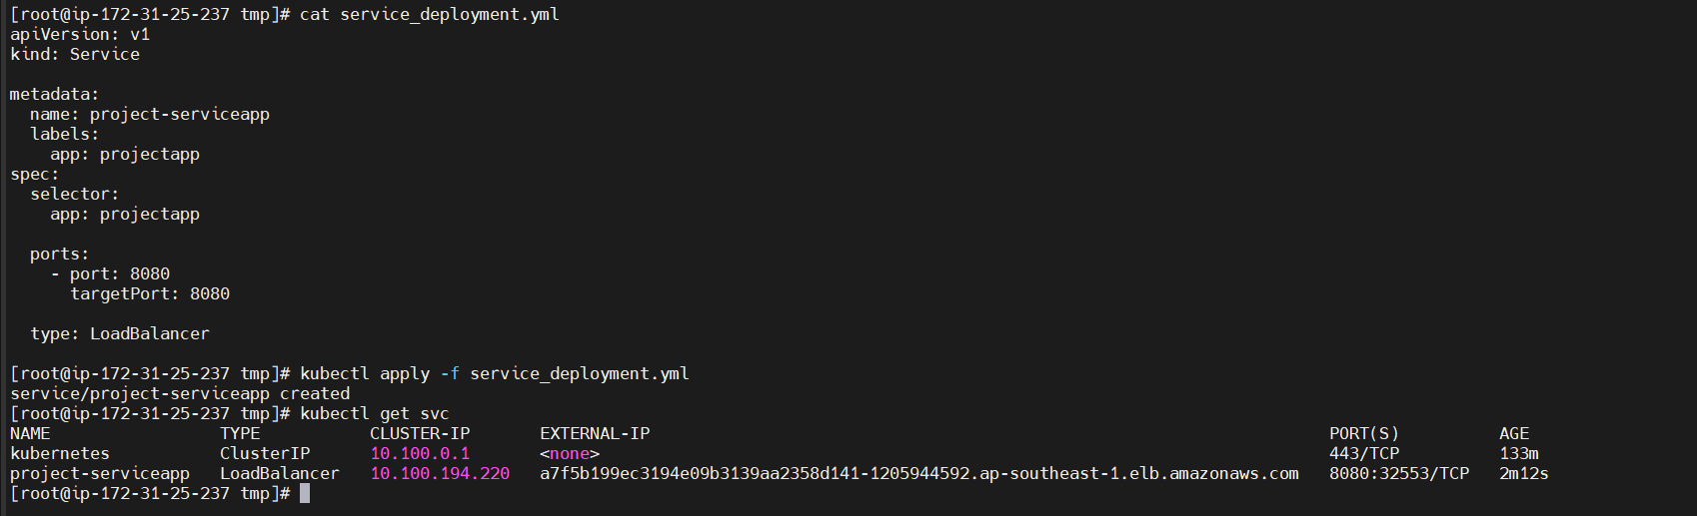  
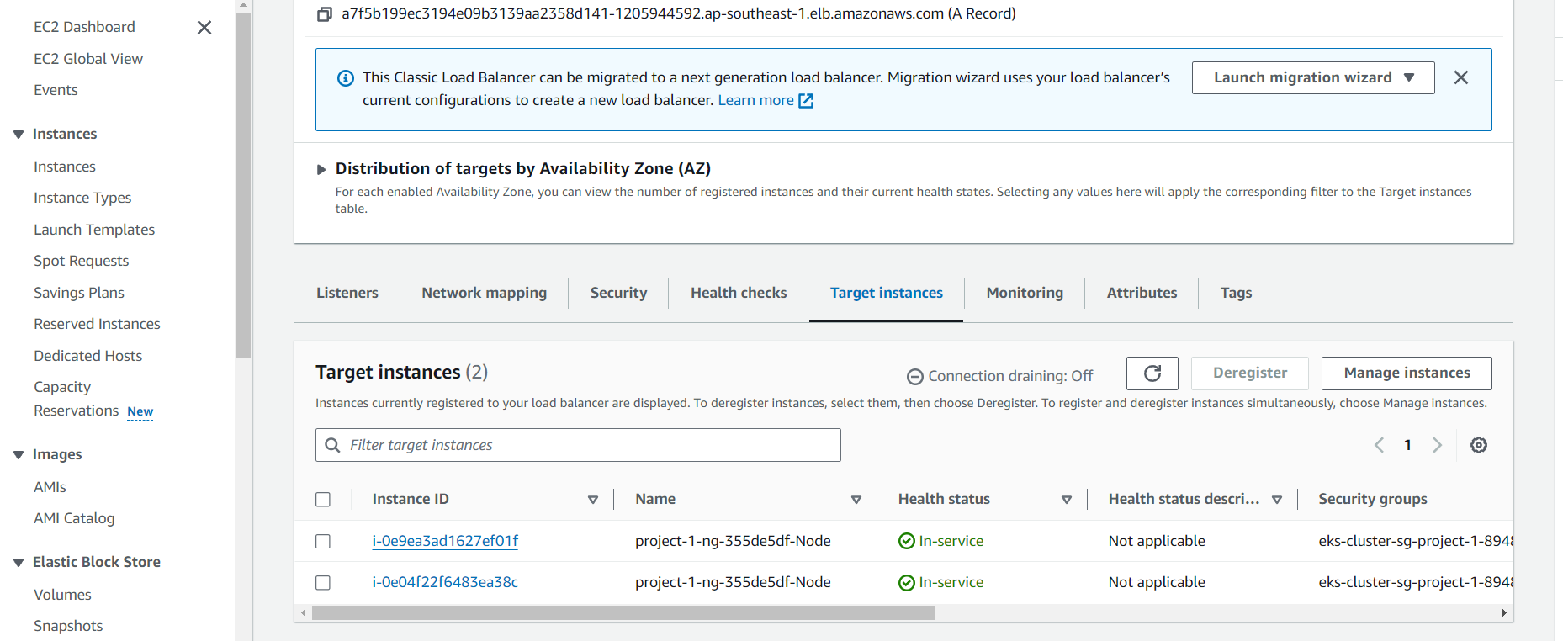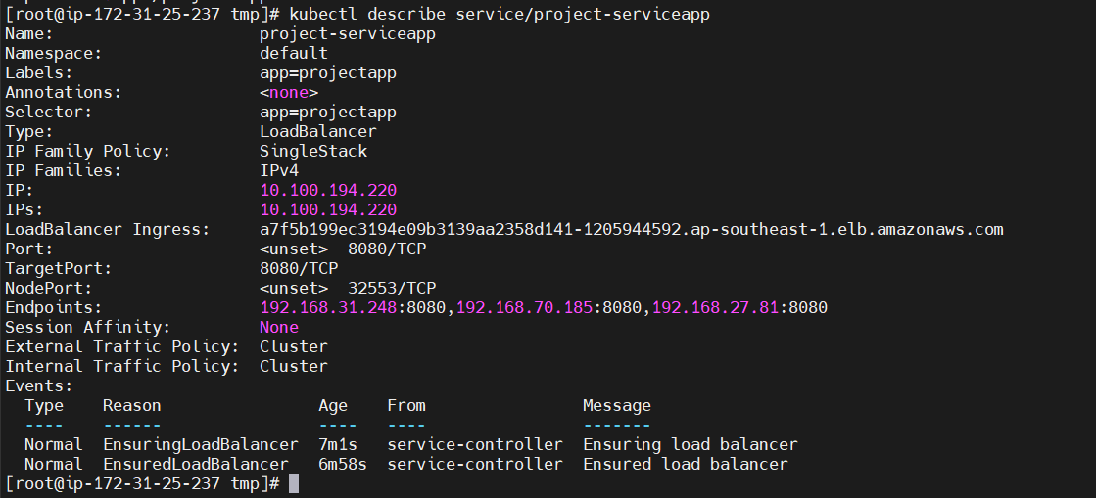**

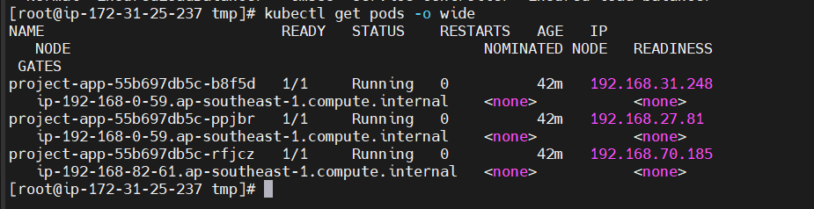

**Output:  
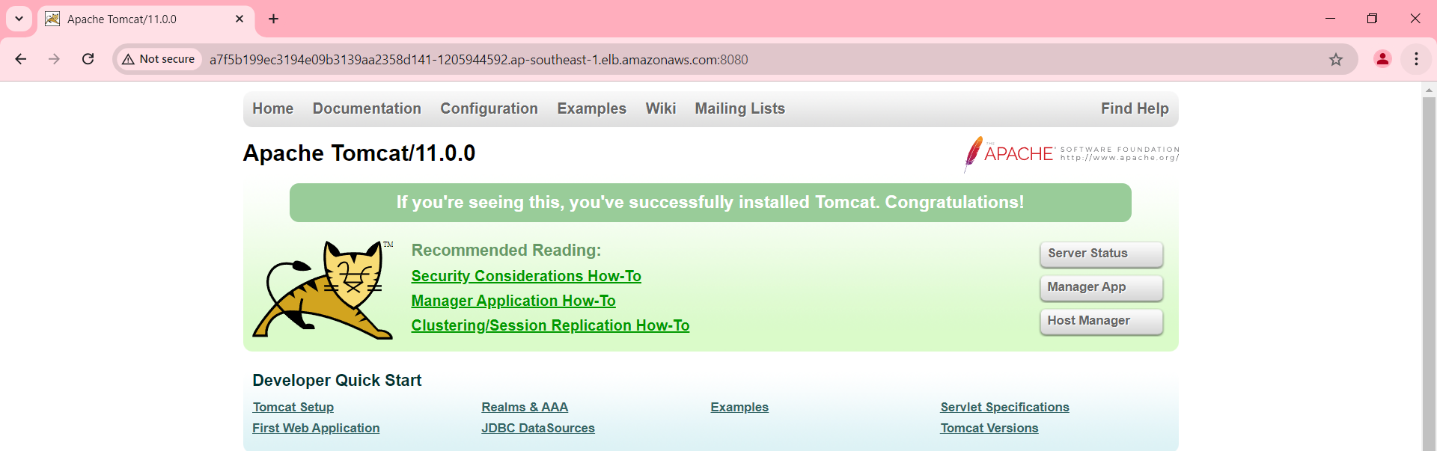  
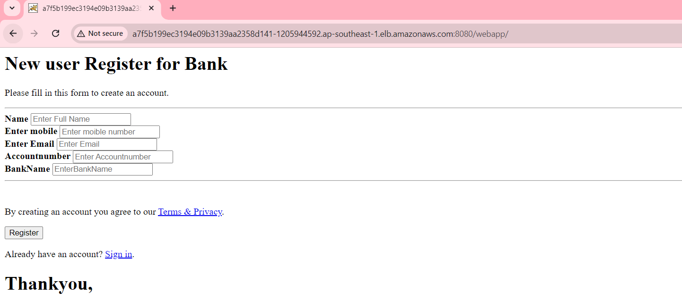  
Deleting the pod and After the new pod:  
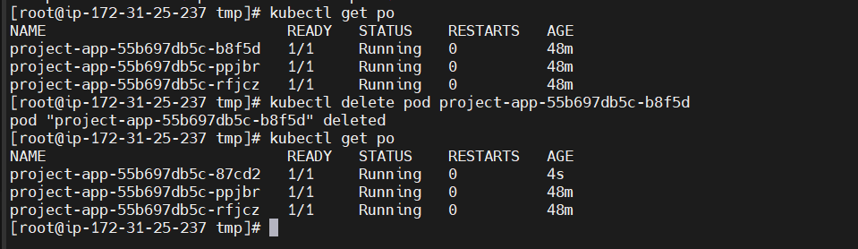**

**Integrate kubernetes with Ansible:  
Adding the ansible user to kubernetes server  
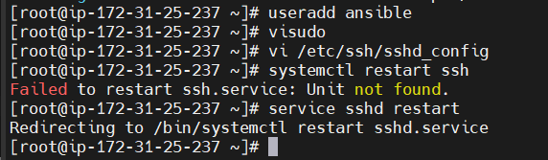  
On Ansible server:  
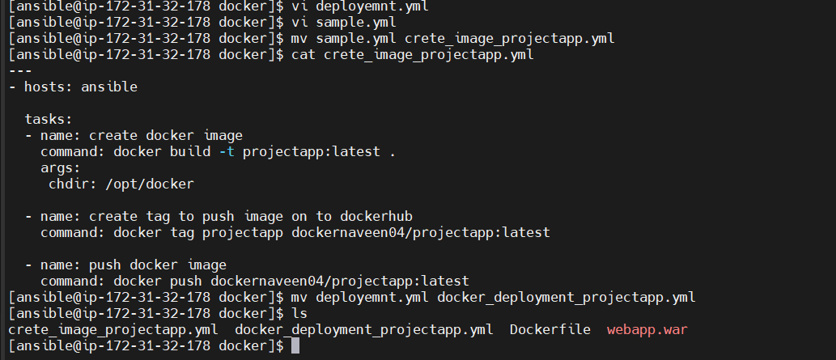  
Creating Host File on Ansible:**

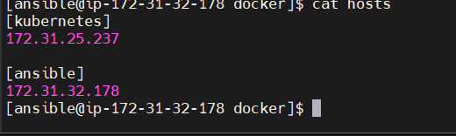

**Copy the ssh-keys:**

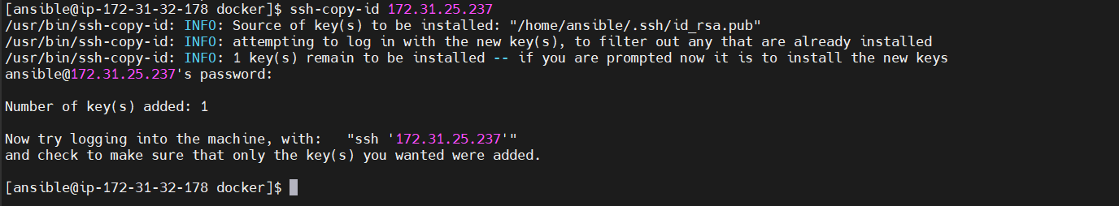

**Checking:  
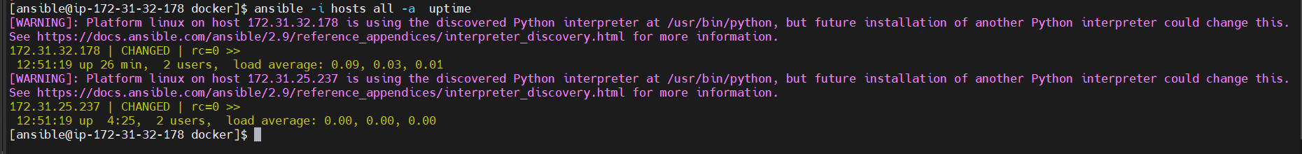  
Creating the config files on Ansible:  
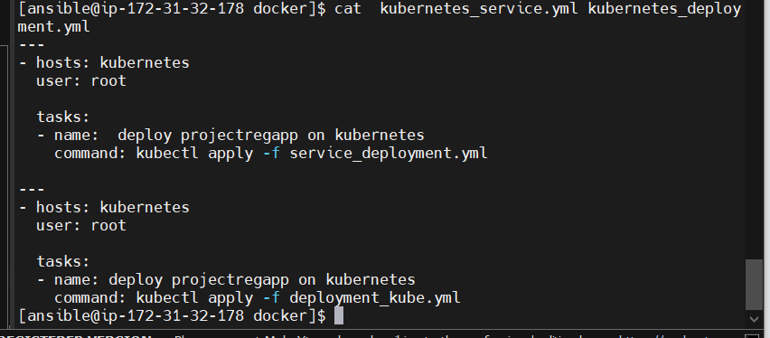  
On Kubernetes server:  
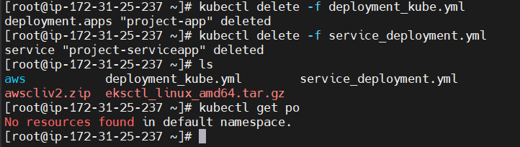**

**Ssh configuration to root user:  
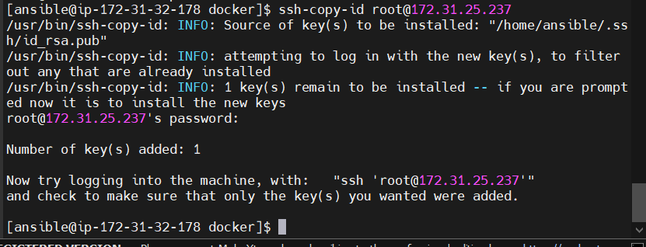  
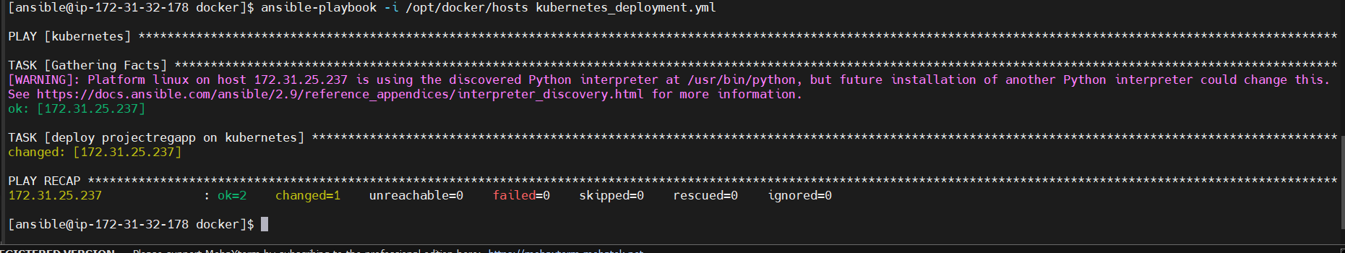  
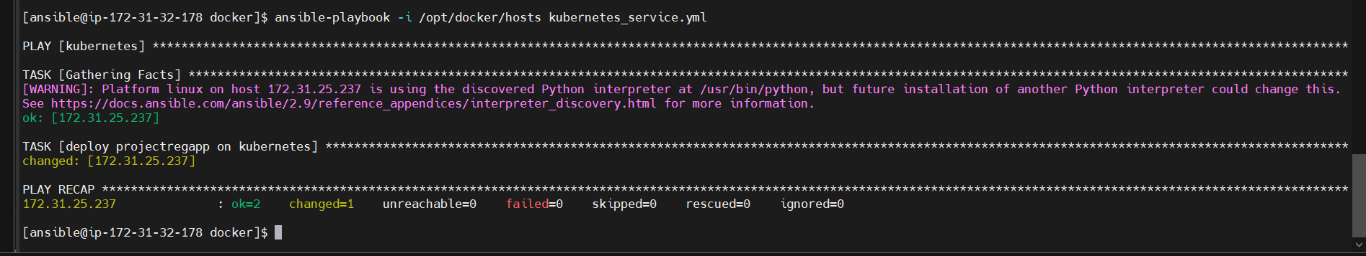  
On Kubernetes server:  
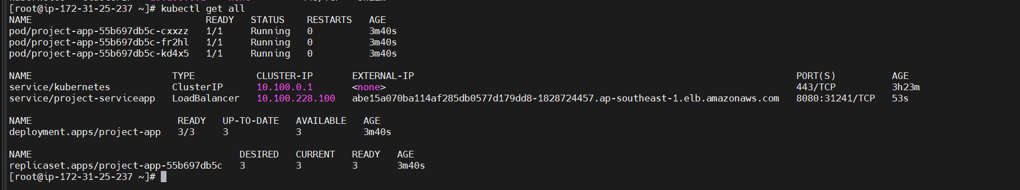**

**On AWS Load Balancers:**

**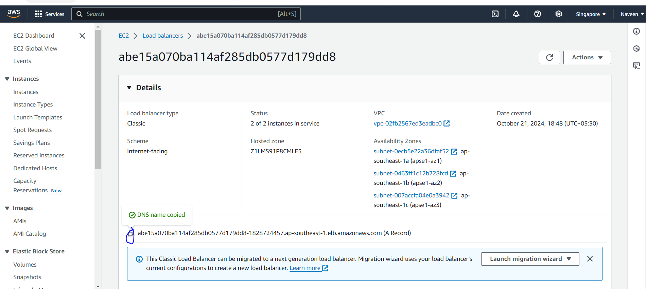  
Output:**

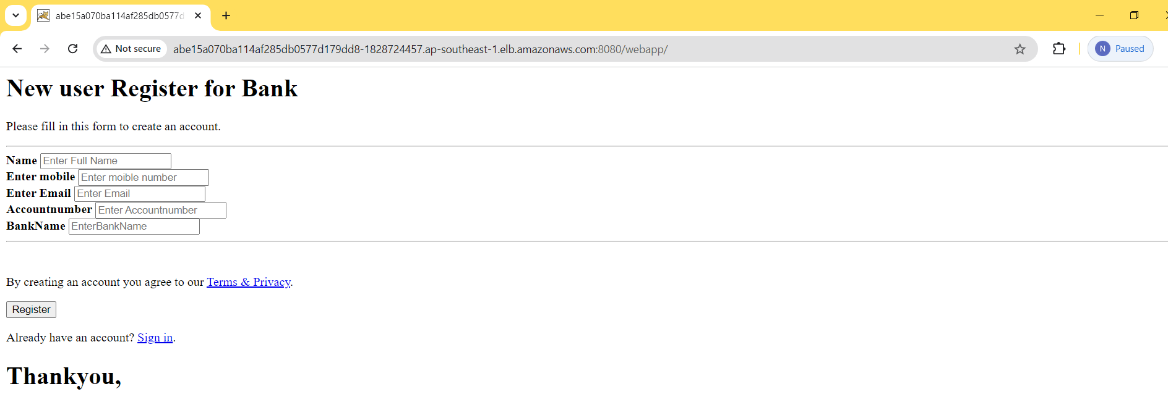

**Creating jenkins jobs for Kubernetes Deployments:  
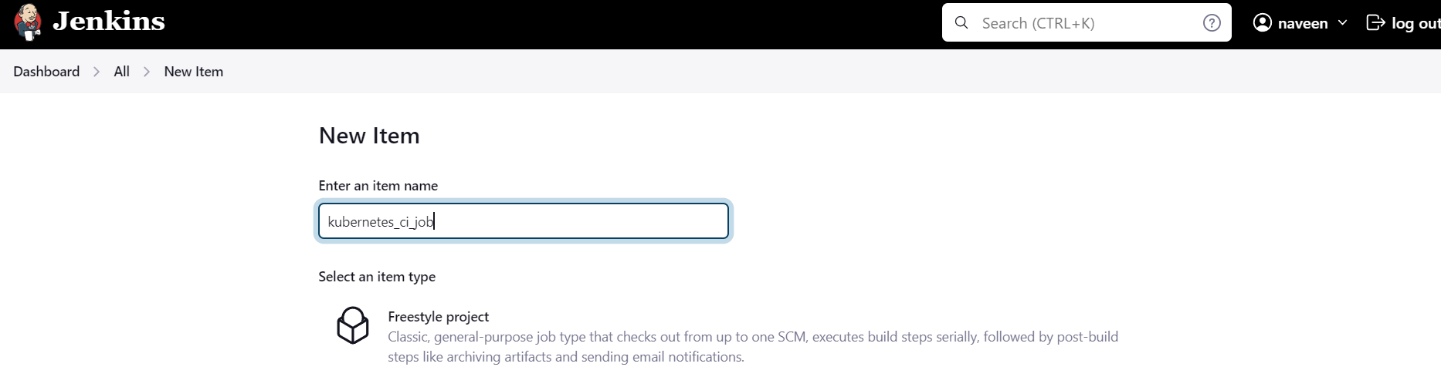**

**Jenkins configurations:**

**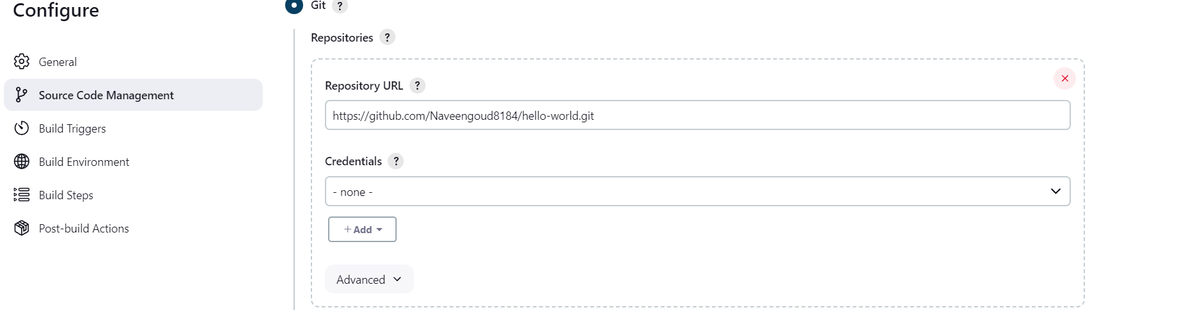  
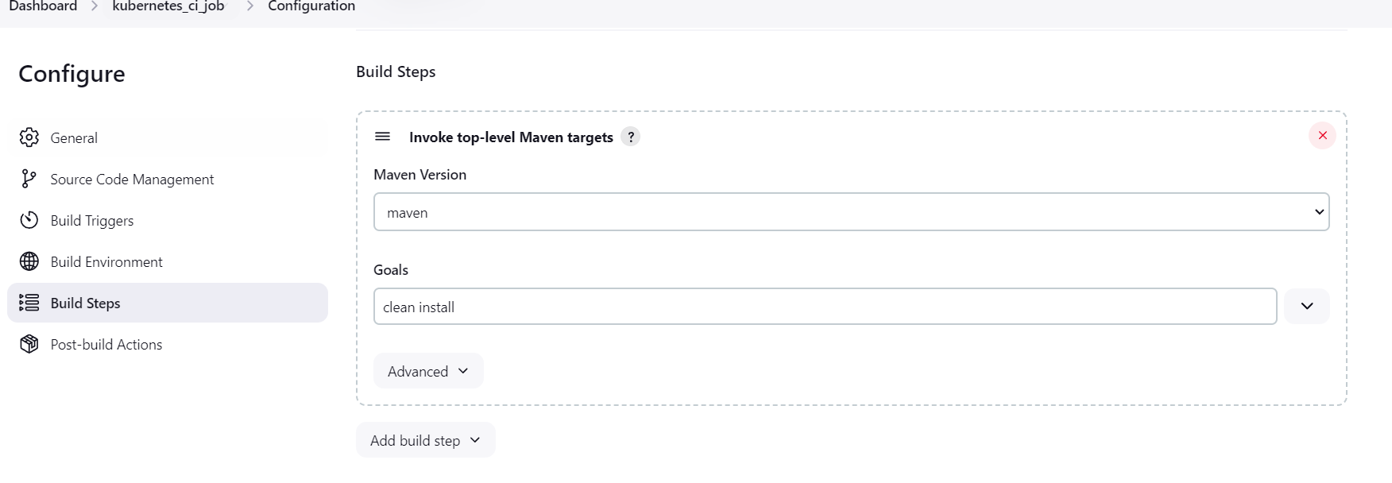  
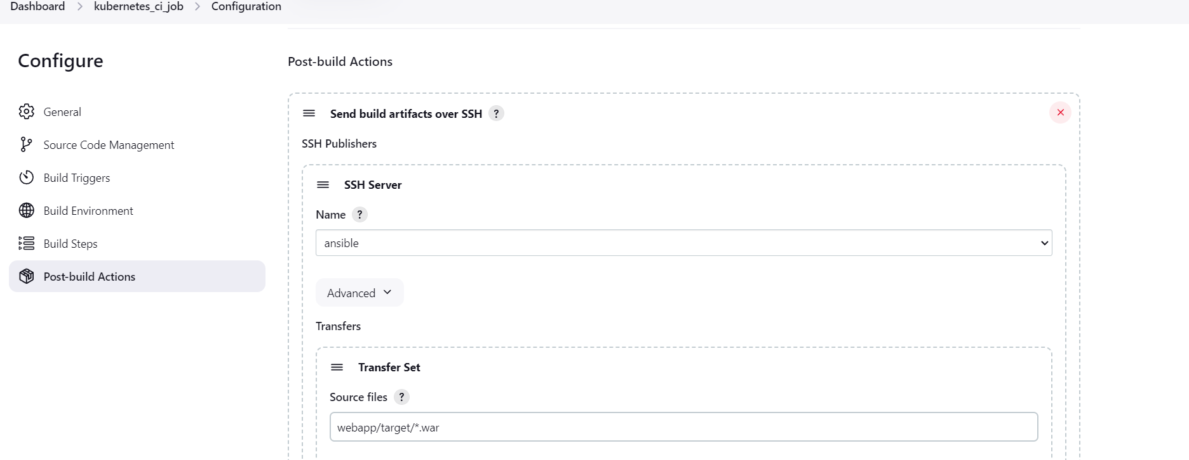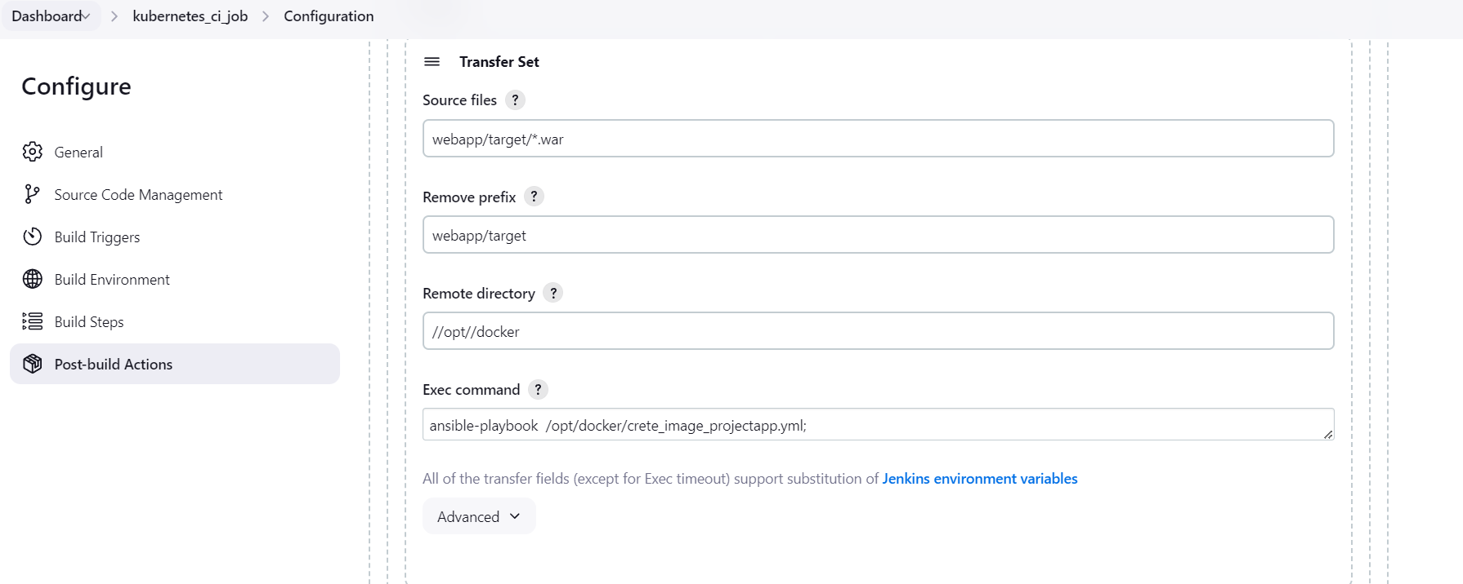  
  
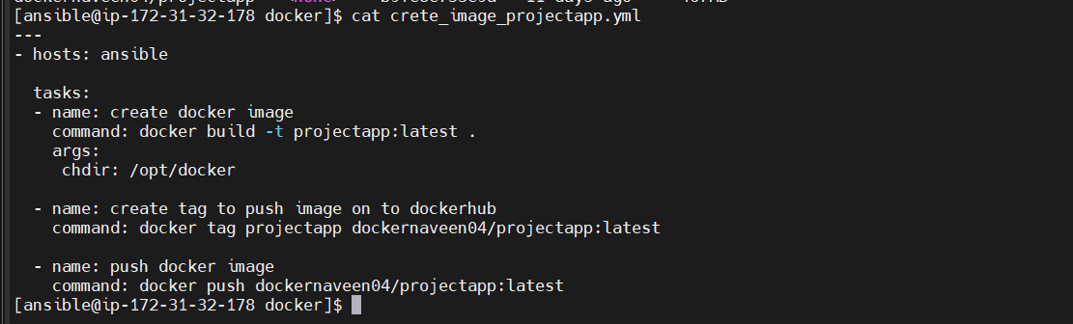  
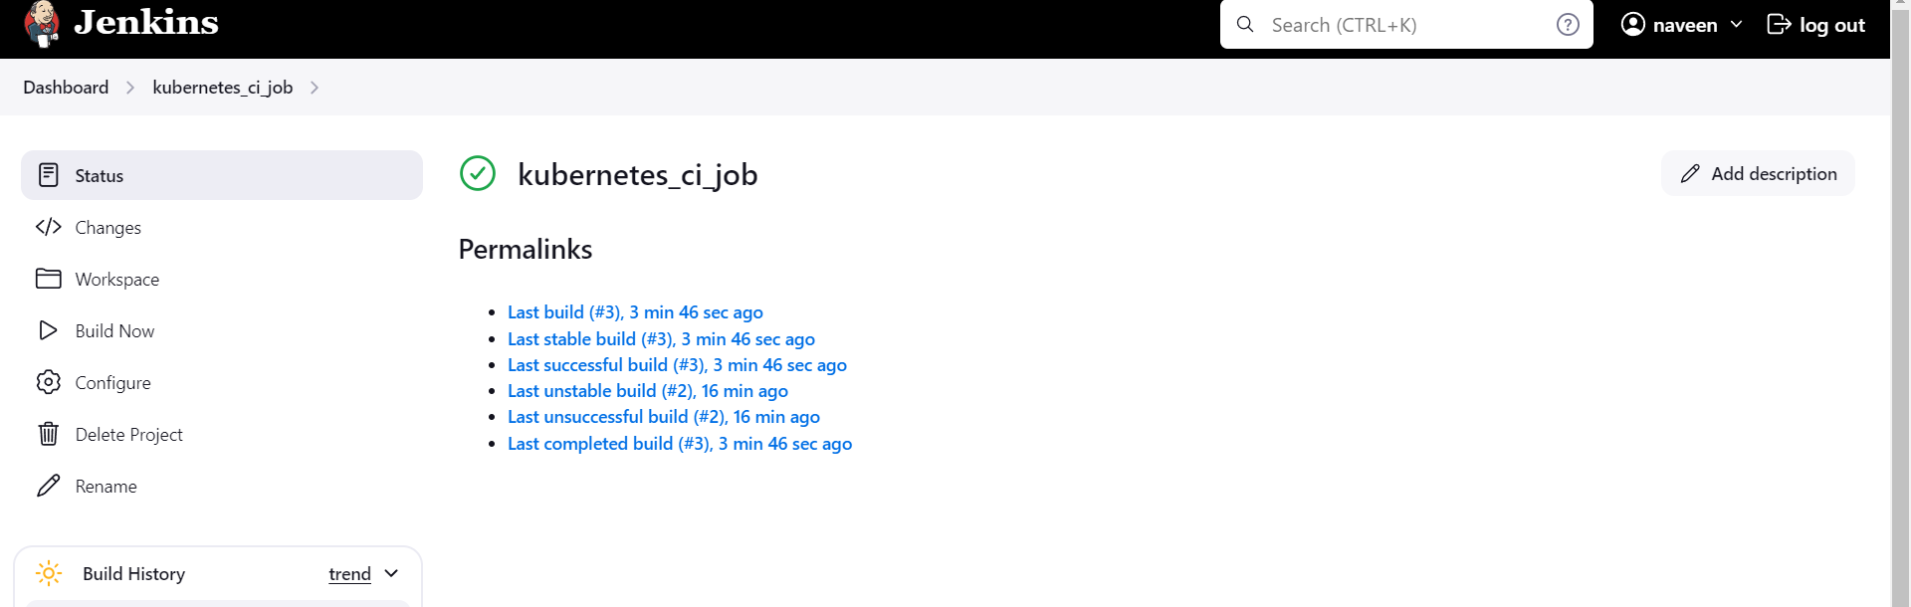  
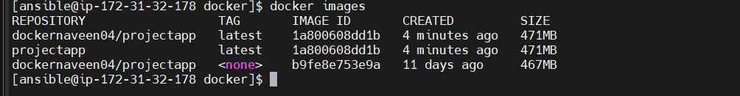**

**Creating the jenkins Deployment Job:  
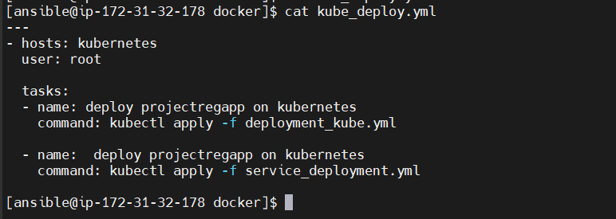  
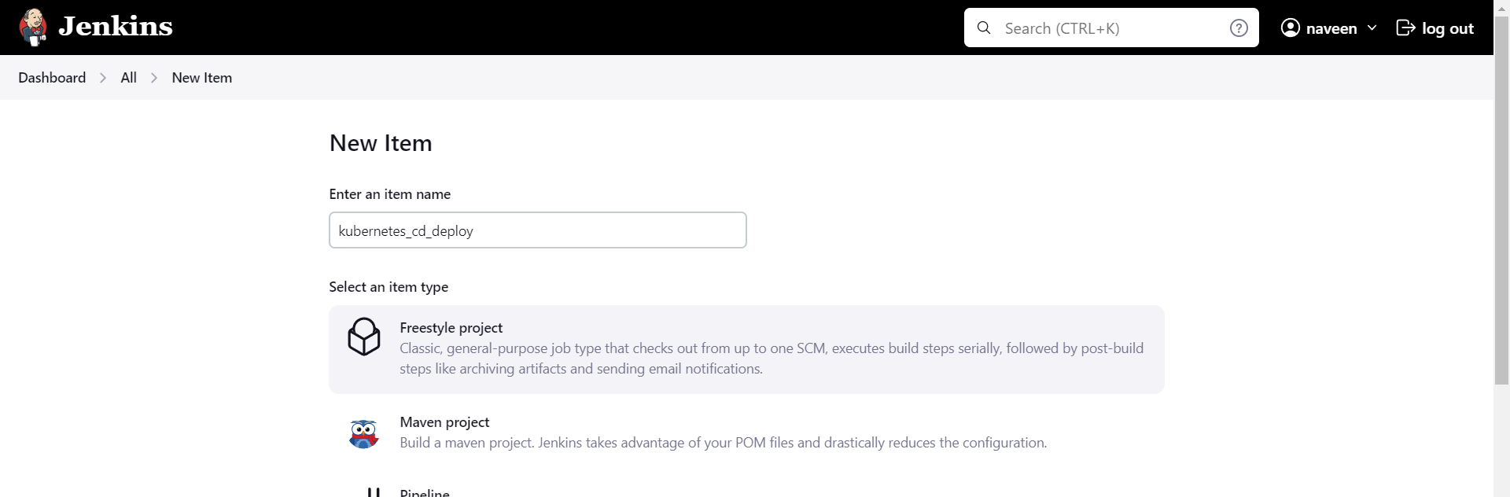  
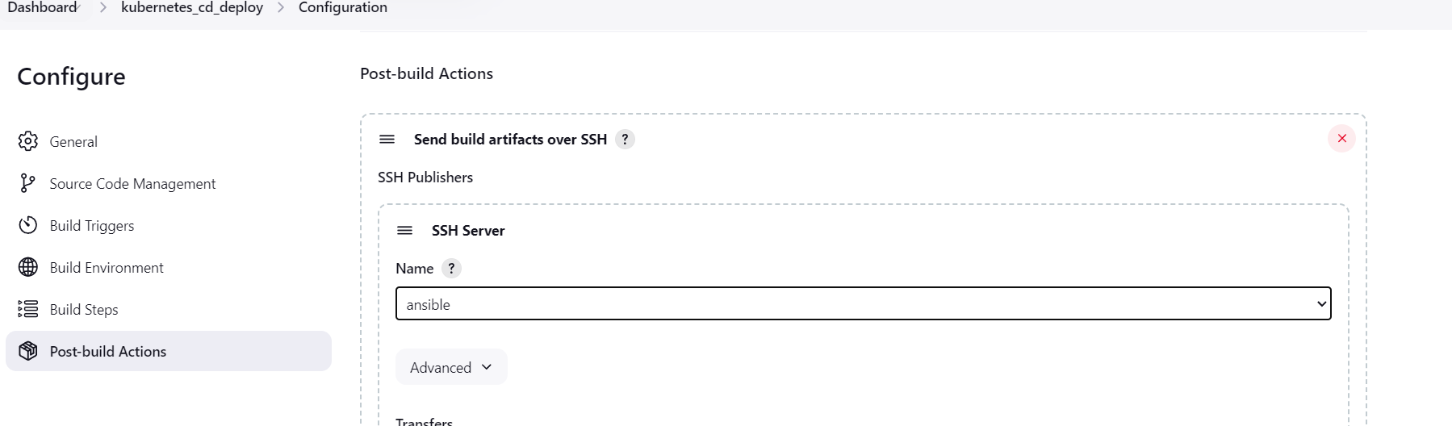  
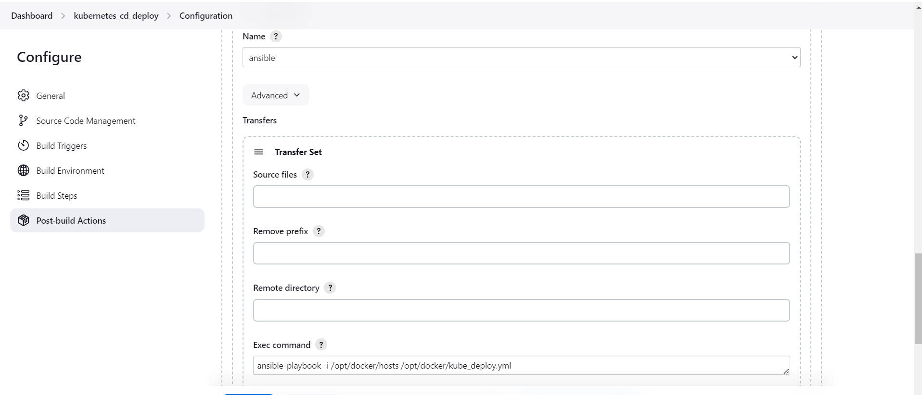  
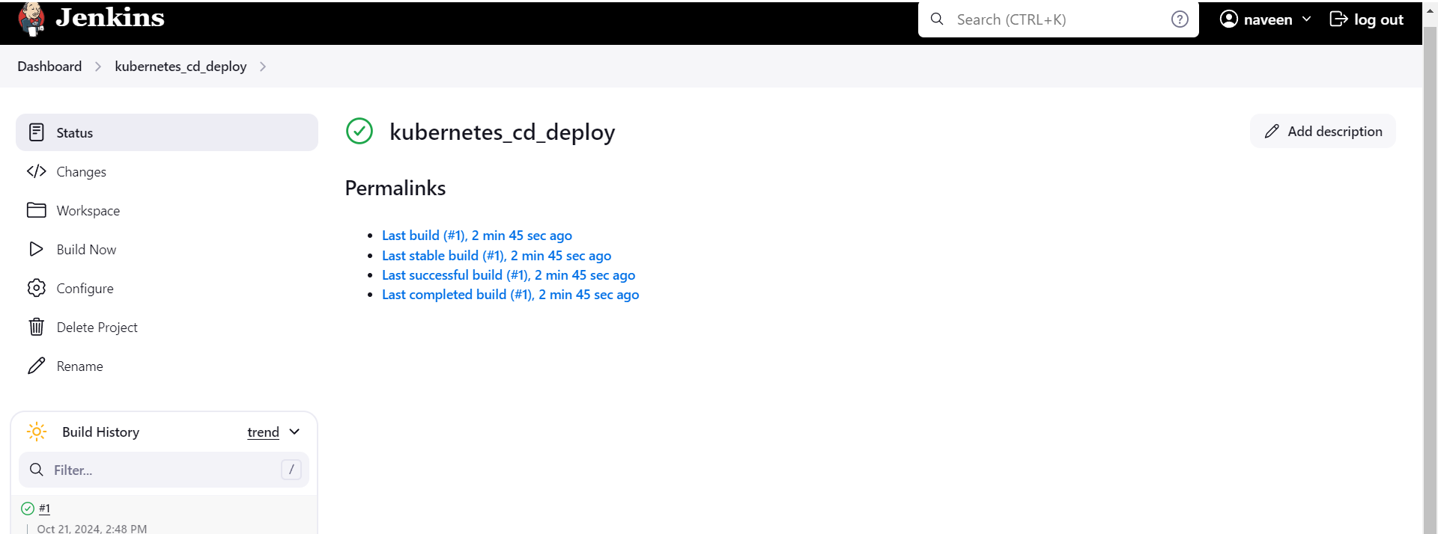  
On Kubernetes:  
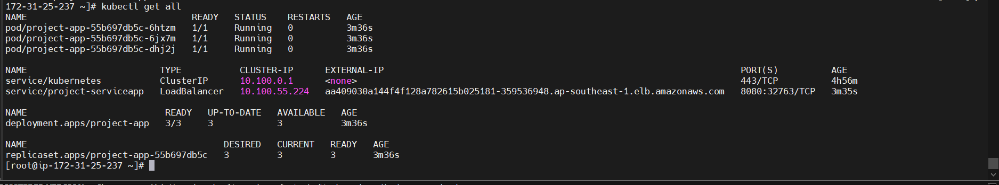  
Configuring The both ci and cd jobs:  
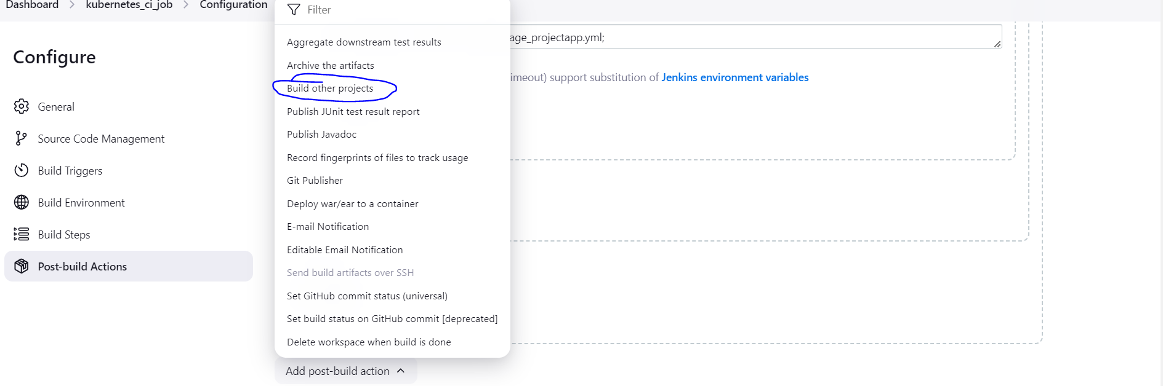  
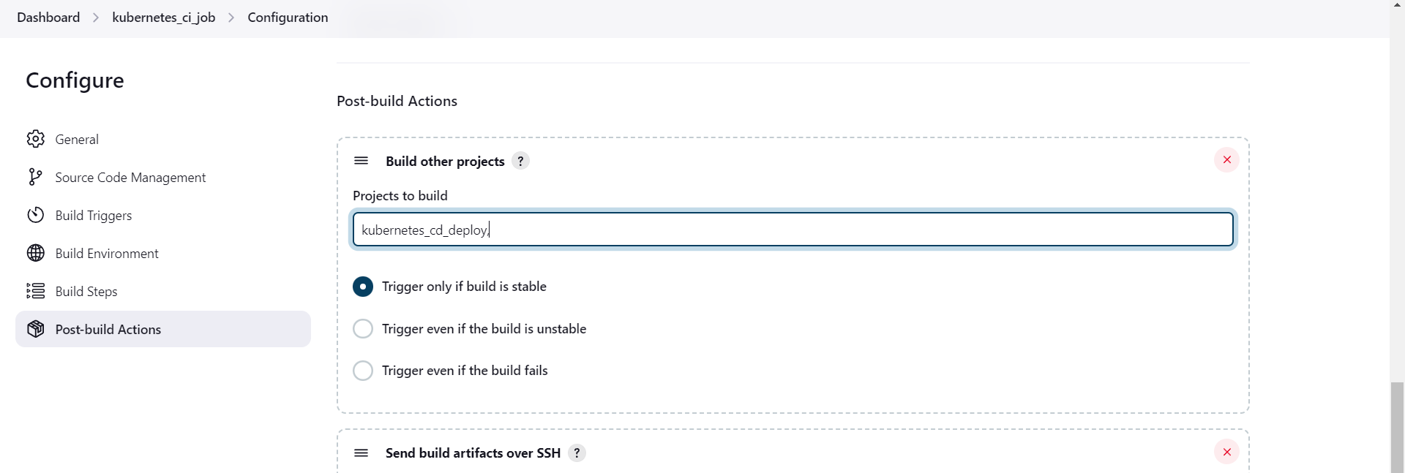**

**On Kubernetes server:  
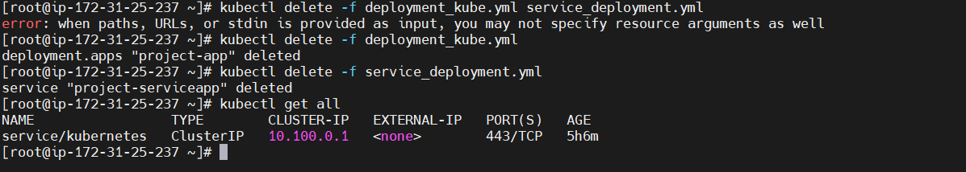  
On Ansible server:  
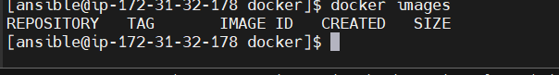  
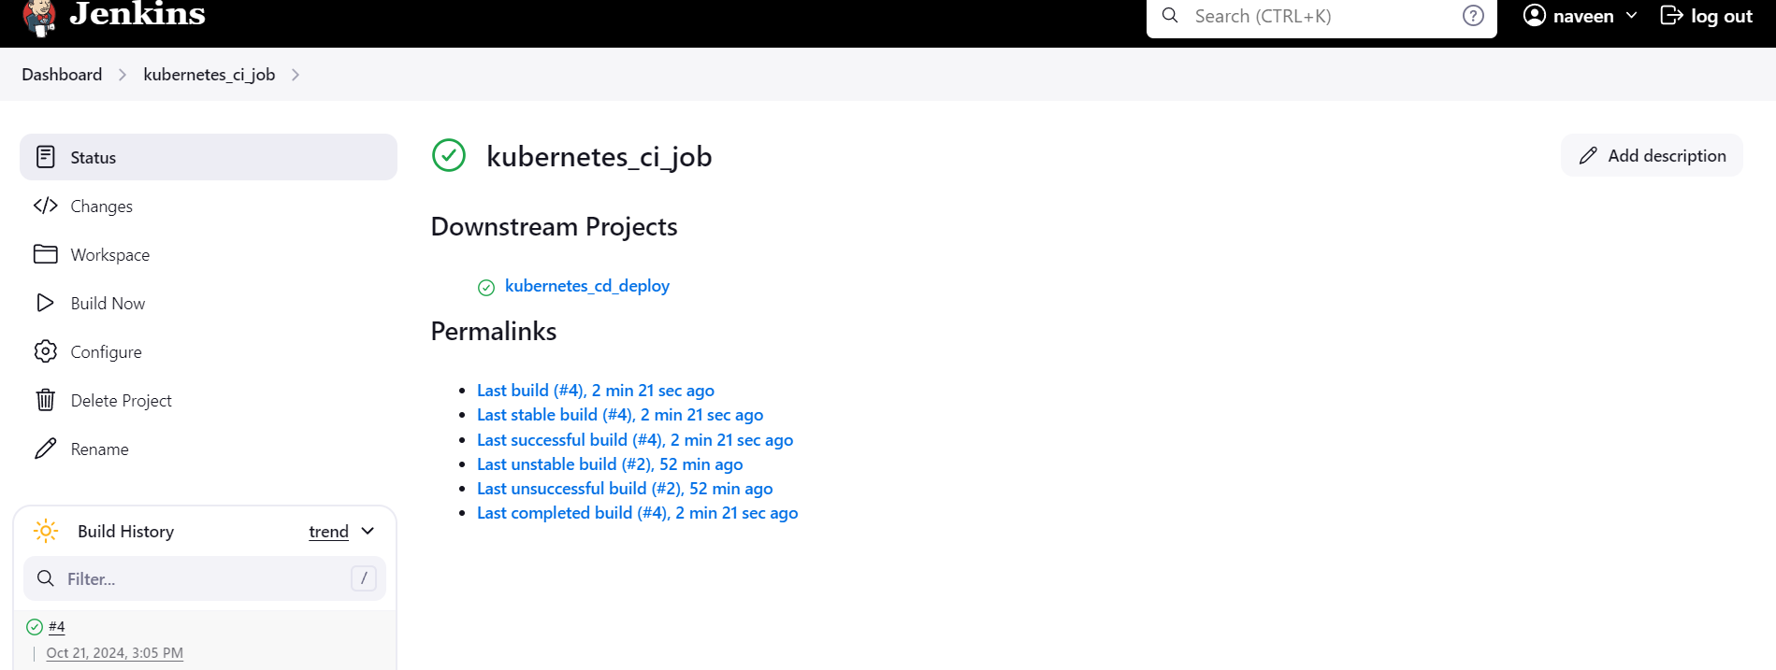  
Ansible:**

**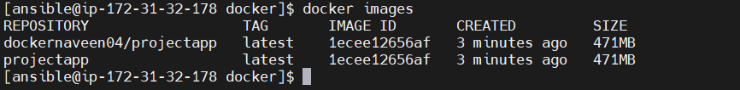  
Kubernetes:  
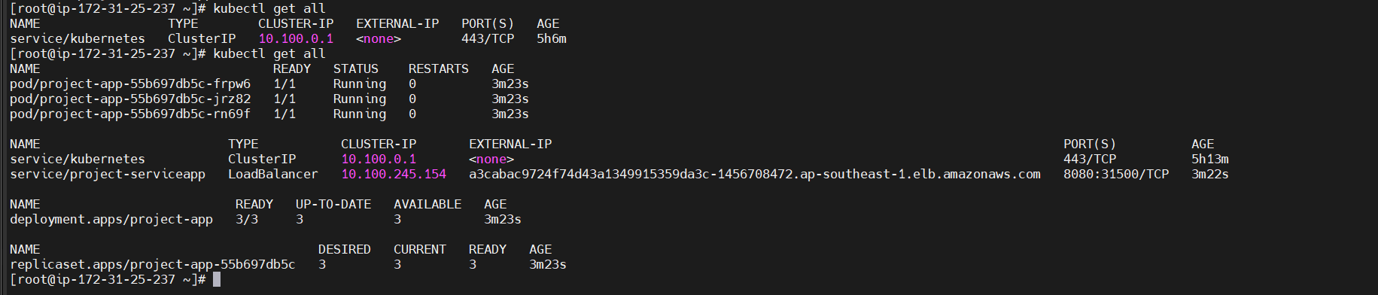**

**Output:  
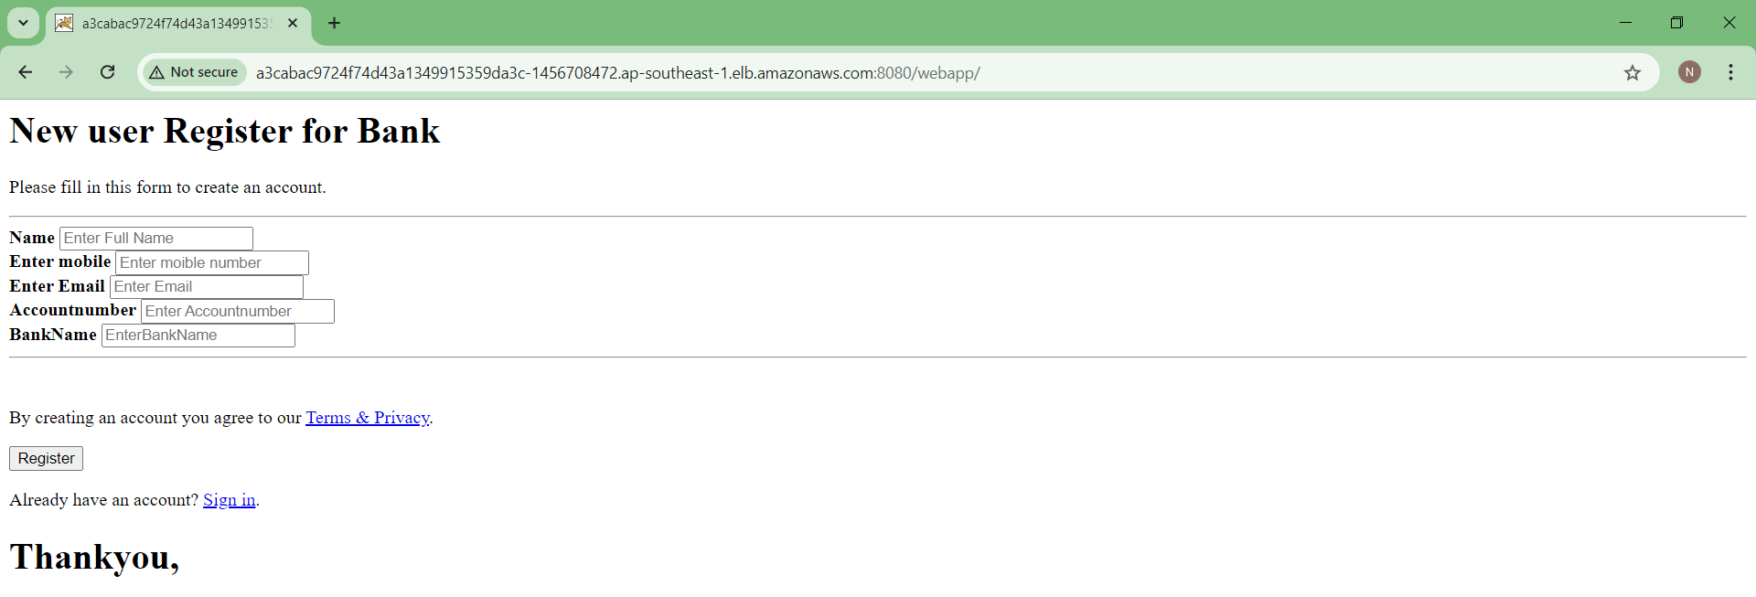**

**LinkedIn: https://www.linkedin.com/in/naveen-70414b238/**